**T.A.P.I. 1.0 - Project** **Plan**



**April 12, 2022**



**Permanent Communications**

**Executive Summary**………………………………….…………………………………….…………………………………………4

**Sponsor Information**………………………………….…………………………………….……………………………………….6

a. Sponsor History………………………………….…………………………………….………….…………………….6

b. Sponsor Organization Chart………………………………….…………………………………….………………9

c. SWOT Analysis……………………………………………………………….…………………………………………10

**Project Objectives**…………………………...……….…………………….…………………………………………….……….12

a. Objective Statement……….…………………………….……………………………………………………….…12

b. Scope Diagram…………………………………….……………….………………….………………………………13

c. Scope Statement………………………………………………………………………………………………………14

**High Level Requirements**…………………………………….………………………………………………………….………16

**Business Case**…………………………………….………………………………………………………………………..………….19

a. Costs/Benefits……….…………………………….…….………………………………………………………….…19

b. Risk and Risk Mitigation……………………….……………….………………….………………………………36

**Planning Assumptions.**……..……………….………………………………………………………………………..………….38

**Project Constraints.**……..……………….…………………………..………………………………………………..………….41

**Project Schedule.**……...……………….………………………………..……………………………………………..………….44

a. Milestones……….………………………………….…….………………………………………………………….…44

b. Gantt Chart……………………….……………….…………………………………….………………………………45

**Project Organization**………………………………..………….………………………………………………………….………46

a. Organization Chart……………………………….…….………………………………………………………….…46

b. Roles and Responsibilities Matrix……………………….…………………….………………………………47

**Communication Plan**………………………….………………………………………………………………………..………….50

a. Communication Overview……………….…………………….……………..………………………………….51

b. Communication Matrix……………….…………………….………………….………………………………….52

c. Elevator Speech……………………………….…….……………….……………………….……………………….55

d. Project Pitch…………………………………….………………………….…………………………….…………….56

**Control Procedures**…………………………………….……………………………………………………………………………57

a. Quality Assurance…………………………………….………………………………………………………………57

b. Progress Control…………………………………….………………………………………….…………………….58

c. Risk Control…………………………………….…………………………………………………………….………….59

d. Issue Management…………………………………….…………………………………………………………….60

e. Problem Reporting…………………………………….……………………………….…………………………….61

f. Change and Exception Handling…………………………………….………………………………………….63

g. Version (Configuration) Control…………………………………….………………………………………….64

h. Team Conflict Resolution…………………………………….……………….…………………………………..66

i. Testing Strategy…………………………………….………………………………………………….……………….67

**Project Summary**…………………………………….…………………………….………………………………….…………….72

**Project Management Lessons Learned**…………………………………….…………………………………….……….73

**References**……………………………….…….……………………………………………………………………………………….76

**Appendix (Additional Project Information)** ……………….…………………….…………………………………….73

a. Work Breakdown Structure…………………………………….…………….………………………………….78

b. PERT Chart…………………………………….……………………………………….………….…………………….83

c. Detailed Problems & Requirements List…………………………………….…………….……………….84

d. Project History……………………………….…….………………………….……………………………………….94

e. Detailed Issue Log……………………………….…….……………………….…………………………………….98

f. Detailed Problem Log……………………………………………………….……………………………………….99

g. Detailed Change Log…………………………………….……………………………….………………………..101

h. Status Reports…………………………………….……………….………………….……………………………..104

i. Final Presentation Slides…………………………………………....…….…………………………………….113

Piping International has been in operation since 2014 and specializes in custom fabricating specialized equipment, pressure vessels, and other custom weldment products. Piping International is also a custom homebuilder that has worked in Houston Texas and its surrounding counties. Piping International prides itself on exceeding our customers’ expectations on every project. Piping International also believe we provide exceptional value through the quality of our work and our commitment to safety, and by delivering products on schedule.

While Piping International does several fabrication projects, another huge revenue stream is custom homebuilding. However, when building a home, Piping International has missed several items when estimating what is affecting their business processes. Their paper and Excel spreadsheet-based project tracking system is inefficient and prevents them from maximizing their revenue. Piping International’s owner currently spends countless hours working on the projects to supplement the loss. With a 40-hour work week this translates to 16 to 20 hours per week. The owner operates as the General Contractor with on average is paid $50 an hour and given a project of 4 to 6 months, we have a minimum operating cost of $30,000 per project for the General Contractor.

Piping International has lost more than $20,000 on a project through improper estimations and missing items that would later force the company to pay out of pocket to correct. On average, it costs Piping International around $40,000 per year in corrections. This lack of organization causes both a loss in immediate revenue as well as future custom homes because of the loss in revenue and project timeline is impacted by the loss.

Piping International has stated that due to these losses and their impact on the project timeline, they have not had any returning investors. In addition, Piping International does not have a web-based application or application portal that could limit the number of potential errors with estimating custom home construction.

Permanent Communications was formed by five University of Houston, Computer Information Systems students seeking their bachelor’s degree in the spring of 2022. Initially, Permanent Communications had challenges in identifying a client and designing a solution that would satisfy both client and academic requirements for the CIS program. Permanent Communications worked with Piping International to perform an analysis, to design and develop a web-based application to address the best possible solution for Piping International’s business needs.

The Permanent Communications team developed a solution called T.A.P.I. (Terry Alleyne Piping International) named after the company's owner and name. T.A.P.I. addressed their business needs and eliminated our client's business weaknesses in estimating by storing previous projects with costs, and the ability to create new projects without missing items.

Permanent Communications implemented a web-based application, called T.A.P.I., with the support of a Mongo database to store the company’s data. The T.A.P.I. projects started in January 2022 and finished in April 2022, with a client application delivery by May 12th, the owner’s birthday. Piping International’s cost for the T.A.P.I. project was $4,300, for the cost of the computing equipment, web hosting, and the sponsor's personal time allocated to the project. The estimated benefits of the project are estimated to be $53,440 over the course of five years.

**Sponsor History**

Terry Alleyne is the sole proprietor of Piping International, LLC. He saw a business opportunity soon after leaving the military but did not have enough capital to start. He started working in refineries in Houston, TX where he started saving money and learning the tricks of the trade in business, fabrication, welding, and construction. When seeing other companies’ workmanship, he knew there were features about fabrication, welding, and construction, that he believed could have been done a lot better. He started his first construction project by building his own home for his family. Using the money and knowledge he learned, he completed his first custom home project in 2013. The project included features such as a third floor with a rooftop balcony, among other things. He had a budget in mind, but his goal was to build it in cash, refraining from taking a bank loan. To get started, he began contacting contractors for the 8 phases of the project. He quickly ran into some complications. Some contractors would not follow up on their quotes and others were simply way above their budget. After seeing the continued trend, he decided to take matters into his own hands.

Terry consulted with a few of his trusted friends and mentioned the details of the project and the issues with contractors and completing tasks. One of his friends and his uncle told Terry about having the ability to construct what he wanted. The three of them discussed the logistics of the project and came across a small impasse. Terry did not have enough lumber to build the 3rd floor with a balcony. One of his friends did not have the necessary resources to deliver but his uncle had extra lumber at an additional cost to the project. His uncle was only able to provide the labor, but Terry had to provide everything else. After Terry was able to obtain the lumber for his new home, the third floor was completed in just two days. In doing so, he realized the immense potential at his disposal. If he could do better at estimating materials for a specific project, things would go smoothly in his future endeavors. In 2014 Terry started Piping International, purchased a one-acre lot for his business, and built a 3,200 square foot shop. At that point he bought tools with his personal credit card and began advertising. He started by bidding for fabrication jobs in the Houston area. He received his first contract in the summer of 2015. At the beginning of 2018, he decided to include custom home building in his business. He contacted a friend from the military that designed a website to advertise his services. Terry started offering outdoor and indoor remodeling services, concrete and landscaping work, and minor plumbing and electrical work. The following year, in 2019, he saw a significant growth in business and decided to build a second house for himself. In 2022 he hired Permanent Communication, a group of IT consultants, to help improve his system of data analysis.

To this day he is constantly working, from the moment he wakes up, to the moment he gets into bed. He is constantly talking to potential investors or one of his many subcontractors about ongoing projects. His main source of marketing is done through his website. He also has a banner on his truck with his contact information. In two short years he has seen a significant increase in his profits. However, his biggest setback is the lack of an efficient system for managing his project, investors, and project data. He stores past projects in filing cabinets and Excel spreadsheets, which presents a tremendous loss of time when referencing specific details about past projects to the Homeowners Association, or the local municipal resources for permits. Our consulting team intends to build a system that will drastically reduce the time it takes him to start a new project, include all the phases, steps, and tasks for the project, reference subcontractors, and investors. We also hope to establish a more digitalized form for data storage that he can access from anywhere on the go. His plans for the next three to five years are for him to step down from the entire process of building a house and allow a Piping International employee to complete the process. We are confident that our system will get him started.

**Client Organization Timeline**

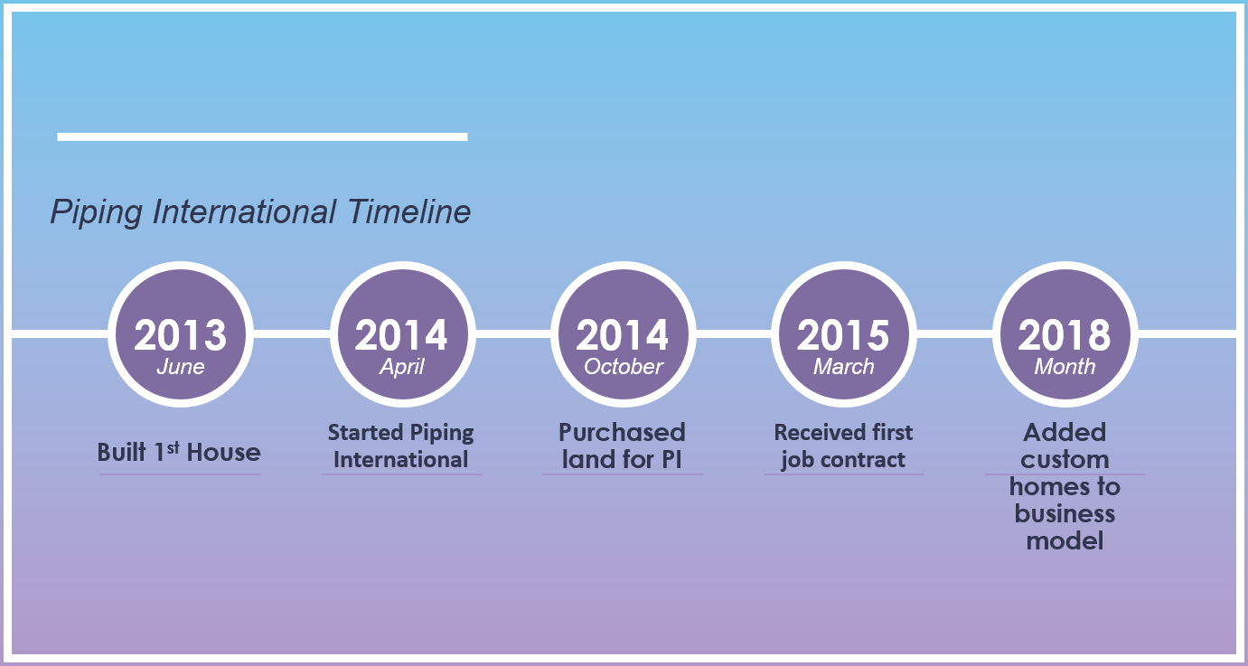

**Sponsor Organization Chart**

Currently Piping International’s sole employee, Terry Alleyne, Owner

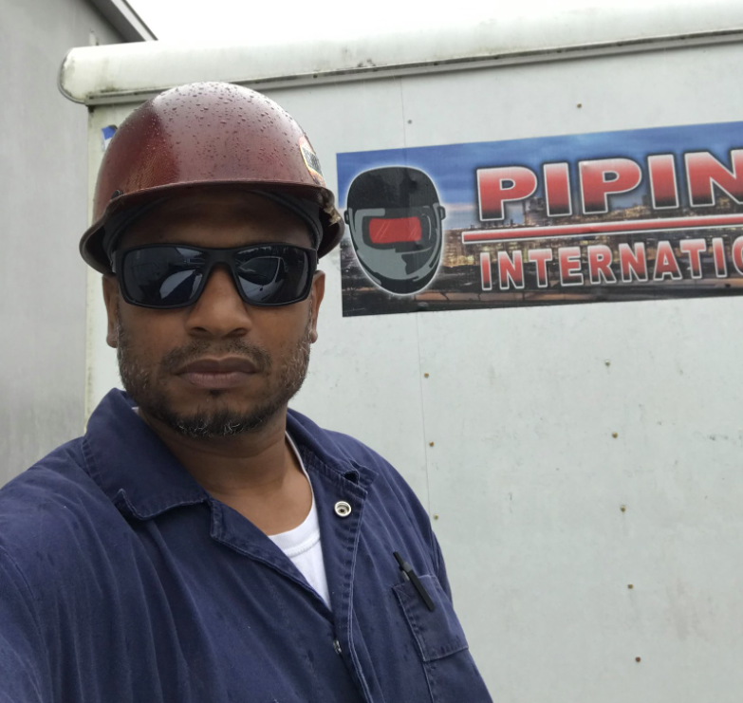

**SWOT Analysis**

|  |  |
| --- | --- |
| STRENGTHS | WEAKNESSES |
| * Highly Efficient * Skilled and Experienced Builder * Cheaper labor costs * Experienced Subcontractors | * Lack of scale. (Small company) * High production and material cost * Availability of unregistered contractors |
| OPPORTUNITIES | THREATS |
| * Possibilities for working on future projects * Hiring new employees as Project Managers * Following the latest building trends | * Highly competitive industry * Weak economic outlook for construction companies * Weather conditions * Covid Quarantine |

**Project Solution**

After identifying the strengths, weaknesses, opportunities, and threats of the client's business using the SWOT analysis, the weaknesses and threats became the focus point in providing a solution to what is hindering Piping International’s business. The Permanent Communications team concluded a solution that would address the business's challenges would be to implement an event management system. The system would consist of a back-end database and front-end graphical user interface that provides input fields and output information for our client, Piping International.

The weaknesses and threats outlined in the SWOT analysis suggested we implement a project tracking system that would reduce the issues caused by the challenges surrounding the list of weaknesses and threats. The purpose of the application and the backend database is to satisfy the needs of the business by solving the issues and meeting the business requirements. The application will address the issue of having a lack of scale by providing a purpose-built application for estimating for projects. The application will have the ability to view previous projects to assist the client with existing and future estimations. The project management will assist with improving efficiency and enhancing productivity. When efficiency is combined with the strengths of Piping International, the results are seen in the financial portfolio as profit margins increase.

**Objective Statement**

To:

* Create a project estimating web-based database application

In a way that:

* Reduces missing items when completing a project
* Reduces missing tasks when estimating a project
* Stores contractor’s contact information and their trades
* Reports on estimated and actual costs
* Reduces estimating errors by reviewing previous projects in the application
* Stores subcontractors contact information
* Creates a user-friendly interface that nontechnical users can easily learn and utilize
* Users of Piping International can view and research related projects

So That:

* Hours spent tracking building tasks are reduced by 25%
* Costs of lost revenue due to missing items are reduced by 40%
* Errors in estimating project costs are reduced by 80%

Can be measured by:

* Decrease customer’s time spent creating and managing projects from 20 hours per week to 10 hours per week which reduces operational costs by $20,000 by the end of the calendar year.
* Reduce costs associated with estimating errors by 70% on the next project.
* Increasing the number of managed projects from 2 to 10 within the next 2 calendar years; resulting in $60,000 of additional projects.

**Scope Diagram**

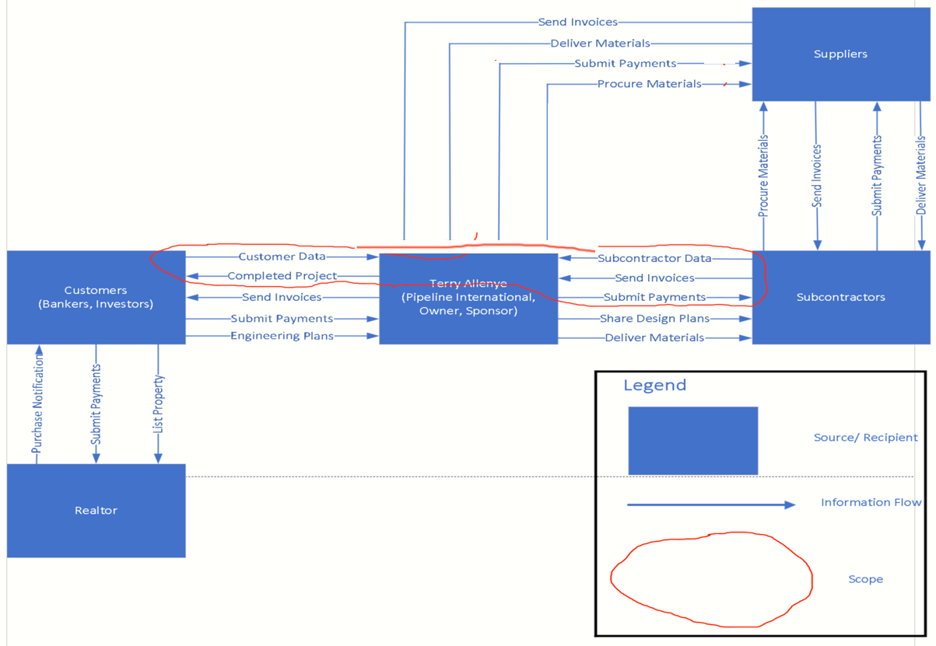

**Scope Statement**

The activities shown above are within our scope for our project and will be reflected in our web application that will allow our sponsor Terry to better manage his projects for Piping International. Piping International interacts directly with its customers and subcontractors: the main activity Piping International receives from customers is the project data. It is Piping International’s job to complete its customers’ projects, who can be bankers or investors. When it comes to subcontractors, the main activities that Piping International needs to store are subcontractor data and invoices. Then Piping International needs to send payments to the subcontractors which are tasked to do various jobs within the project work breakdown structure. Piping International also interacts with suppliers but the suppliers as recipient are not within the scope as Piping International is not specifically tracking supplier data. Instead, the data that goes from Piping International to suppliers are within the scope, more specifically submitting payments to suppliers as well as procuring materials. These activities are being tracked, as our sponsor Terry was losing money because he could not track the expenses from making payments to procure materials from suppliers.

Now, focusing specifically on Terry (Piping International) and Customers (Bankers, Investors) there is no tracking of invoices sent from Terry to the customers. This is out of scope, as Terry did not specify within his requirements for our Web Application that we had to track his invoices sent to the Customers; that was something that he would conduct privately. Also, Terry validated that we were not responsible for tracking the payments he made to the customers as that was to be conducted outside of our web application scope. This would also apply to tracking the engineering plans that customer would send to Terry. These plans are not part of the web application requirements lists. As these plans are to be manipulated within Terry’s privacy, having these plans on the internet would put at risk his customers engineering plans to be manipulated. To continue, when focusing on Terry and the subcontractors, Permanent Communications is not responsible for tracking the design plans that Terry gives to the subcontractors, because that information does not benefit Terry in terms of the web application as it has no usage to him. It is only beneficial for the subcontractor that is responsible for reading the design plans of a building structure and making it come to life. One last item that Terry exchanges with subcontractors is providing them with materials that can be utilized to construct a building. Now, Permanent Communications is not responsible for tracking every time that Terry provides subcontractors materials like wooden planks, sheet rock, insulation, pipes, etc. That is out of scope for Terry’s web application as he mentioned to us that his problem is not inventory related when Terry is providing subcontractors building materials.

Additionally, analyzing the information flow between subcontractors and suppliers is outside of the scope. The main reason being that Terry does not oversee the data that is exchange between subcontractors and suppliers. Therefore, Permanent Communication is not responsible for tracking the information flow within the web application. As the procurement of materials and submitted payments made by subcontractors to suppliers will not be tracked within the web application as that is outside of the scope and that information would not solve a problem in the requirements list. This would also apply to the invoices sent and delivered materials that suppliers provide to subcontractors which Permanent Communication will not be tracking in web application. This is also reflected in the requirements list which highlights what will not be implemented in the web application based on Terry’s requirements. Lastly, the information flow between the customers and realtors is outside of the project scope. As the listing of property and submitted payments is strictly info that a realtor deals with, Terry does not have tracking that based on his requirements for the web application. The purchase notification that a realtor sends to a customer is not within the scope or a requirement that Terry has for Permanent Communications. That information flow is only between a realtor and a customer and is not part of Terry’s business operations, so it is not something that needs to be tracked to improve his business model operations.

**1. Data Inputs and CRUD Functionality:** The Piping International Application, TAPI 1.0, will allow the sponsor to create, delete, update, and view all employees, investors, and subcontractors associated to the company as well as information pertaining to projects initiated by Piping International followed by their respected phases, steps, and tasks. The input forms must allow entry for all new personnel information and all new project information with the ability to update them when deemed necessary. Furthermore, the web app should be built in such a way that allows the client to assign any existing personnel within the application its’ associated issuance via project or job step. The application is to be designed with the ability to create, view, edit, and delete any WBS structures associated to a project as well as allow for the completions of entries. The T.A.P.I. application must also eliminate the use of tracking projects by spreadsheets. Finally, the T.A.P.I. application must be simplistic and easy to use.

**2. Application Reporting:** The T.A.P.I. Application should encompass reports based on Terry’s requirements which Permanent Communication is responsible for implementing. A series of reports regarding project information, personnel information, and resource information is to be produced among all existing data entered and stored. These reports are to provide a great benefit for the sponsor regarding improvements in management of subcontractors, investors, employees, and the entirety of projects. There are six total reports constructed to viably cover multiple interests of the company that the client would need to be aware of on a weekly or daily basis. These reports have extremely easy accessibility as it only takes the click of a button to see the reported results.

**3. Data Integrity & Cost Reduction:** The T.A.P.I. application must have a built-in validation function by making sure all required fields are filled out and that optional fields may be left blank. Cost will be reduced when completing projects, for missed job steps and lack of memory will not be an issue when documenting all data within the web app, instead of onto a spreadsheet, as data will always be stored unless manually deleted. The T.A.P.I. application allows for a great tracking system as every listing of an entity is laid out in a neat table format with sticky headers when scrolling to help reduce the amount of manual entry errors, because of the no predecessor validation within the application.

**4. Technology Access of the Application:** The web application must be compatible for use on desktop computers and laptops primarily. The T.A.P.I. application software developers and Piping International employees will need access to the application, in which currently the client is the sole employee of the business. All other “employees” are outsourced holding the title of contractor and will not have willing access to the application. The T.A.P.I. application must allow only the owner of the company access, as the web application will be constructed for internal use only. Server deplorability will be assessed but the actual web application will run locally on the sponsor’s operating system.

**5. Application Durability/Reliability/Resilience:** The T.A.P.I. Application should function consistently and reliably with few to no glitches or blunders. All data will be stored within a MongoDB database which will hold any all and any statistics entered by the user (client). The contents of the database will have backups and methods for recovering from downtime, damage, or any other calculated issues. All stored, inputted data will be available within the structure of the web application and can be manipulated or altered at any point in time. If hardcoded items such as dropdown lists or Booleans need updating, the sponsor would have to contact Permanent Communications directly to seek the update.

**6. Application Style and Consistency:** The T.A.P.I. Application will stay true to the color scheme, and consistent with the format and layout throughout the entirety of the program. A style guide was conducted and served as a template by design to keep T.A.P.I. Application consistency on every web page. A flash gallery was also implemented on the home/dashboard screen to serve as an appealing background upon the client’s request. Company and team logos were branded onto the navigation bar to secure all copyright reserved.

**7. Data Defaults and Simplicity:** The T.A.P.I. Application will have numerous defaulted values upon the creation of a system’s entity. Moreover, all country fields will be defaulted as “United States.” All state fields will be defaulted as “TX.” All project WBS completion percentage fields will be defaulted at “0%”. And all project WBS status fields will be defaulted as “Not-Started.” The phase and step attributes within an existing project will have dropdown list capability only displaying the same reoccurring phases and steps of a project, because the client requested that every construction process follows the same procedures except at the task level. Also, the table format display on every core page has a built-in filter system as well as a sticky navigation bar and column headings. Finally, the navigation bar contains only a six-button layout for an extremely simplistic style and straightforward use with a built-in sticky “scroll up” button at the bottom of every page. It makes for easy navigational use throughout the app.

**Costs/Benefits Analysis**

Piping International’s core business goal is to provide fabrication and custom home building to the greater Houston area. Piping International’s strategic goals involve growth and profitability. In August 2014, Piping International’s business was formed, and a website was created to attract potential clients and investors. However, Piping International has stumbled across some challenges when estimating for new projects. Terry allowed Permanent Communications to analyze his current environment and agree upon a solution for his problem. Permanent Communications supported this goal by increasing the visibility of the business services to new and current customers by implementing an order system management system that will track customers and order information.

Current Situation:

Piping International has lost more than $20,000 on a project through improper estimations and missing items that would later force the company to pay out of pocket to correct. On average, it costs Piping International around $40,000 per year in corrections. This lack of organization causes both a loss in immediate revenue as well as future projects because of the loss in revenue and impact on the project timeline. Terry has managed most of his project via spreadsheets and memory. Terry spends on average 1 to 2 days estimating for a new project. The current methodology for Terry is keeping everything in a spreadsheet, on paper in a filing cabinet, or by memorizing the project requirements, price, and items needed.

**Business Case Breakdown**

|  |  |  |  |  |  |  |
| --- | --- | --- | --- | --- | --- | --- |
| **Benefits** | **Year 0** | **Year 1** | **Year 2** | **Year 3** | **Year 4** | **Year 5** |
| Reduction of Office Supplies | N/A | $1,743.02 | $2,178.78 | $2,614.54 | $3,050.29 | $3,486.05 |
| Increase revenue by reducing time | N/A | $48,480.00 | $50,419.20 | $51,388.80 | $52,358.40 | $53,328.00 |
| **Total benefits:** | $0 | **$50,223.02** | **$52,597.98** | **$54,003.34** | **$55,408.69** | **$56,814.05** |

**Costs/Benefits**

**Benefit 1:**

By using this web application, Piping International will drastically reduce their expenditure on office supplies. Currently, Piping International spends $4,357.56 every month on stationery, including pens, paper, notebooks, and printer ink. More specifically, every month they spend $19.73 on notebooks, $25.47 on 8.5x11 printing paper, $22.49 on packs of sticky notes, $6.98 on pen packs, $60.49 on black ink cartridges, and $75.99 on yellow/cyan/magenta ink cartridges each. By the end of the first year of the application’s implementation, Piping International’s stationery expenditure is projected to decrease by 40%, saving them $1,743.02 every month in expenditures. By the end of year two, these savings should increase to 50%, saving them $2,178.78. Then in year three, these savings will increase again to 60%, saving them $2,614.54. In year four, to 70%, saving $3,050.29. Finally in year five, increase savings to 80%, saving Piping International $3,486.05 every year in office expenditures. By the end of the fifth year of operating this web app, Piping International will only be spending $871.51 on office supplies, down $3,486.05 from $4,357.56.

These will take place by reducing Piping International’s reliance on printing, writing, and physically recording information and documents. Saving documents digitally means having to print less, reducing the need to purchase printing paper and ink cartridges. It also means having to buy fewer notebooks and pens, since all their information is recorded in the database.

**Benefit 1 Calculations:**

**Year 1: Monthly Office supplies costs:**

Notebooks pack of 12 = $19.73

Printing paper Letter (8.5x11) 1,500 sheets = $25.47

Sticky notes pack of 24 x 70 sheets = $22.49

Pens 50 pack = $6.98

Printer Black Ink = $60.49 (1,300 sheets)

Printer Yellow Ink = $75.99 (1,300 sheets)

Printer Cyan Ink = $75.99 (1,300 sheets)

Printer Magenta Ink = $75.99 (1,300 sheets)

**Total costs:** $19.73 + $25.47 + $22.49 + $6.98 + $60.49 + $75.99 + $75.99 + $75.99 = $363.13 *12 = **$4,357.56**

**40% costs reduction = $4,357.56 * 40% = $1,743.02**

**Year 2: Monthly Office supplies costs:**

Notebooks pack of 12 = $19.73

Printing paper Letter (8.5x11) 1,500 sheets = $25.47

Sticky notes pack of 24 x 70 sheets = $22.49

Pens 50 pack = $6.98

Printer Black Ink = $60.49 (1,300 sheets)

Printer Yellow Ink = $75.99 (1,300 sheets)

Printer Cyan Ink = $75.99 (1,300 sheets)

Printer Magenta Ink = $75.99 (1,300 sheets)

**Total costs:** $19.73 + $25.47 + $22.49 + $6.98 + $60.49 + $75.99 + $75.99 + $75.99 = $363.13 * 12 = **$4,357.56**

**50% costs reduction = $4,357.56 * 50% = $2,178.78**

**Year 3: Monthly Office supplies costs:**

Notebooks pack of 12 = $19.73

Printing paper Letter (8.5x11) 1,500 sheets = $25.47

Sticky notes pack of 24 x 70 sheets = $22.49

Pens 50 pack = $6.98

Printer Black Ink = $60.49 (1,300 sheets)

Printer Yellow Ink = $75.99 (1,300 sheets)

Printer Cyan Ink = $75.99 (1,300 sheets)

Printer Magenta Ink = $75.99 (1,300 sheets)

**Total costs:** $19.73 + $25.47 + $22.49 + $6.98 + $60.49 + $75.99 + $75.99 + $75.99 = $363.13 * 12 = **$4,357.56**

**60% costs reduction = $4,357.56 * 60% = $2,614.54**

**Year 4: Monthly Office supplies costs:**

Notebooks pack of 12 = $19.73

Printing paper Letter (8.5x11) 1,500 sheets = $25.47

Sticky notes pack of 24 x 70 sheets = $22.49

Pens 50 pack = $6.98

Printer Black Ink = $60.49 (1,300 sheets)

Printer Yellow Ink = $75.99 (1,300 sheets)

Printer Cyan Ink = $75.99 (1,300 sheets)

Printer Magenta Ink = $75.99 (1,300 sheets)

**Total costs:** $19.73 + $25.47 + $22.49 + $6.98 + $60.49 + $75.99 + $75.99 + $75.99 = $363.13 * 12 =**$4,357.56**

**70% costs reduction = $4,357.56 * 70% = $3,050.29**

**Year 5: Monthly Office supplies costs:**

Notebooks pack of 12 = $19.73

Printing paper Letter (8.5x11) 1,500 sheets = $25.47

Sticky notes pack of 24 x 70 sheets = $22.49

Pens 50 pack = $6.98

Printer Black Ink = $60.49 (1,300 sheets)

Printer Yellow Ink = $75.99 (1,300 sheets)

Printer Cyan Ink = $75.99 (1,300 sheets)

Printer Magenta Ink = $75.99 (1,300 sheets)

**Total costs:** $19.73 + $25.47 + $22.49 + $6.98 + $60.49 + $75.99 + $75.99 + $75.99 = $363.13 * 12 = **$4,357.56**

**80% costs reduction = $4,357.56 * 80% = $3,486.05**

***By the end of the fifth year of using our solution, Piping International should be spending only (*yearly office supplies cost) $4,357.56 - (80% cost reduction)$3,486.05 *= $871.51 for office supplies.***

**Benefit 2:**

Piping International’s yearly revenue amounts to $48,480.00 per year, or $4,040 per month on average. This number was obtained by calculating average monthly revenue ($6,540) subtracted by average monthly expenses ($2,500) to receive a monthly revenue ($4,040), multiplying that by 12 to get yearly revenue ($48,480) Through the usage of this project’s web application, we expect to steadily increase this over the next five years. Our client has experienced losses of revenue through poor management and missed payments. This project’s web application was created to assist and enhance our client’s ability to record, manage, and track business information through its database and report generation functions.

By the end of the first year, revenue is projected to not change significantly, as our client will still be familiarizing himself with its functions. By the end of the second year, however, revenue is expected to increase by 4% to $50,419.20 from our client’s current revenue because of our web application enhancing their business management. By the third year, revenues should increase by 6% of the original revenue to $51,388.80. The fourth year should see revenue increase to 8%, to $52,358.40. And finally, in the fifth year, revenues should increase to $53,328. This steady increase in revenue comes from the client growing more familiar with our web application and utilizing it to its fullest potential.

**Benefit 2 Calculations:**

**Year 1:** Avg. Monthly Rev. –Average Monthly Expense = Monthly Revenue * 12 months

$6,540.00 - $2,500 = $4,040.00 * 12 months = **$48,480.00**

So, the average monthly revenue is the typical profit that Terry makes when working on a given project. Then the average monthly expense is the typical expense that Terry incurs when working on a given project for a client.

**Year 2:** Based on an increase in profits and expenses of 4%

**$48,480.00 + ($48,480.00 * 4%) = $50,419.20**

**Year 3:** Based on an increase in profits and expenses of 6%

**$48,480.00 + ($48,480.00 * 6%) = $51,388.80**

**Year 4:** Based on an increase in profits and expenses of 8%

**$48,480.00 + ($48,480.00 * 8%) = $52,358.40**

**Year 5:** Based on an increase in profits and expenses of 10%

**$48,480.00 + ($48,480.00 * 10%) = $53,328.00**

**Year 0 Cost (Development)**

|  |  |  |  |
| --- | --- | --- | --- |
| **Development Costs** | **Hours** | **Rate** | **Total** |
| Team | 763 | $30 | $22,890 |
| Client | 12 | $100 | $1,200 |
| Professor Detillier | 30 | $150 | $4,500 |
| Will Rubit | 3 | $75 | $225 |
| MongoDB Atlas |  | $0 | $0 |
|  |  |  |  |
| Total Costs |  |  | $28,815 |
| UH Discount |  |  | ($27,615) |
| Overall Development Cost |  |  | $1,200 |

**Operational Costs Summary**

|  |  |  |  |  |  |  |
| --- | --- | --- | --- | --- | --- | --- |
|  | **Year 0** | **Year 1** | **Year 2** | **Year 3** | **Year 4** | **Year 5** |
| Licenses | N/A | $1,425.19 | $1,480.19 | $1,480.19 | $1,480.19 | $1,480.19 |
| Upgrades Equipment | N/A | $1,007.67 | N/A | N/A | N/A | $949.99 |
| Maintenance | N/A | $360 | $360 | $360 | $360 | $360 |
| Enhancements | N/A | N/A | N/A | N/A | N/A | N/A |
| Printing Costs | N/A | $2,076.91 | $1,730.76 | $1,384.61 | $1,038.46 | $692.30 |
| Backup & Recovery | N/A | $0 | $0 | $0 | $0 | $0 |
| **Total** |  | **$4,509.77** | **$3,570.95** | **$3,224.80** | **$2,878.65** | **$3,482.48** |

**Licenses**

MongoDB

The MongoDB Atlas database is a multi-cloud application data platform. It uses a document model map that uses JSON to record data in the database, which is why we chose this option instead of others since it allowed our application to directly access the data without converting it in the frontend. Our recommended subscription model for our client be the dedicated plan, starting from $57 per month or $684 per year. The MongoDB database can help the application by providing statistical information on existing data from its data stores, thus helping Terry in finding insight into his projects.

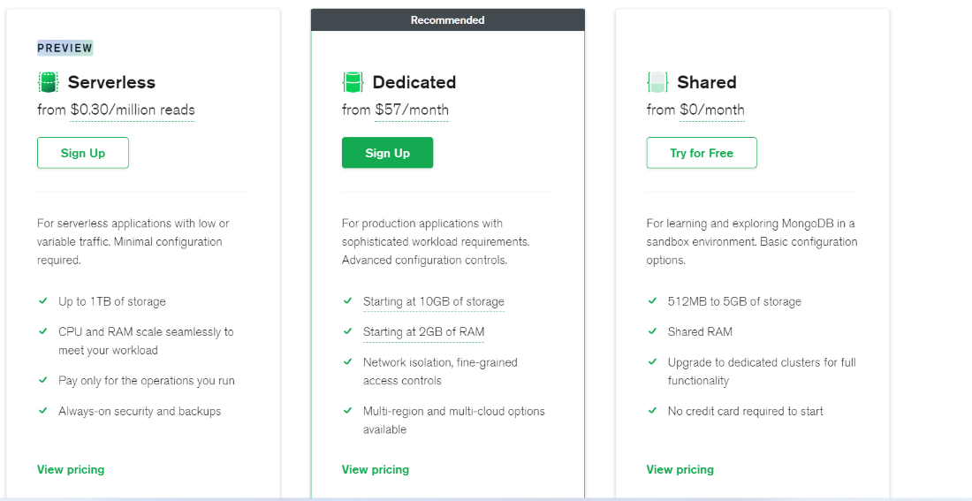

***Figure 1 Dedicated Plan for MongoDB $57***

MongoDB can be configured to back up its data via snapshots that the server will create after a set amount of time. It will also utilize Amazon Web Services M10 Cluster, which has 10 GB of storage and 2 GB of ram. Base prices are currently 0.08 cents per hour or $691.20 per year. If terry increases his storage after 2+ years, he may change to an M20 cluster and would have to pay 0.20 cents per hour or $1720 per year.

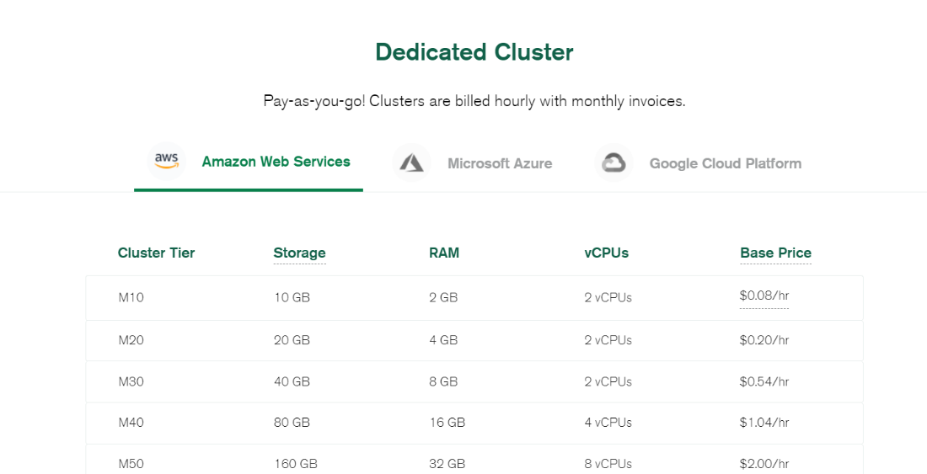

***Figure 2: Mongo Dedicated Cluster using Amazon AWS M10 Tier***

**Norton360 Ultimate**

The Norton360 Ultimate subscription has a suite of features which help in application and network security, cloud backups, and password protection. Through the ultimate subscription, the cost for the subscription would be $49.99 for the first year, then $104.99 for renewals. This ensures that the data is not compromised while conducting networking operations on the server. This also gives Terry access to the LifeLock program, which checks if any of the data listed from the server might have been compromised.



***Figure 3: Norton 360 Deluxe $49.99***

**Licenses Calculations**

**Year 1:** MongoDB Dedicated subscription - $57 * 12 = $684 per year

MongoDB M10 Cluster – $0.08/hour * 24 hours * 30 days * 12 months = $691.20

Norton360 Deluxe- $49.99 1st year

**Total Cost = $1,425.19 per year**

**Year 2:** MongoDB Dedicated subscription - $57 * 12 = $684 per year

MongoDB M10 Cluster – $0.08/hour * 24 hours * 30 days * 12 months = $691.20 per year

Norton360 Deluxe- $104.99 per year

**Total Cost = $1,480.19 per year**

**Year 3:** MongoDB Dedicated subscription - $57 * 12 = $684 per year

MongoDB M10 Cluster – $0.08/hour * 24 hours * 30 days * 12 months = $691.20 per year

Norton360 Deluxe- $104.99 per year

**Total Cost = $1,480.19 per year**

**Year 4:** MongoDB Dedicated subscription - $57 * 12 = $684 per year

MongoDB M10 Cluster – $0.08/hour * 24 hours * 30 days * 12 months = $691.20 per year

Norton360 Deluxe- $104.99 per year

**Total Cost = $1,480.19 per year**

**Year 5:** MongoDB Dedicated subscription - $57 * 12 = $684 per year

MongoDB M10 Cluster – $0.08/hour * 24 hours * 30 days * 12 months = $691.20 per year

Norton360 Deluxe- $104.99 per year

**Total Cost = $1480.19 per year**

**Total Costs:** $1,425.19 + $1,480.19 + $1,480.19 + $1,480.19 + $1,480.19 = **$7345.19**

**Upgrade Equipment**

In Year 1, Piping International will purchase a Lenovo IdeaPad 5i 15.6” Laptop Computer for the purpose of running the web application. The monitor and wireless mouse will help our client use the web application in his office, but he will be able to take the laptop with him if he needs to leave the office. The external hard drive will also help the client backup their data offline, enhancing their data’s integrity. Around years 4 or 5, our clients should consider replacing or upgrading their equipment to keep up with the market and to deal with their old equipment’s wear and tear.

Upgrade Equipment Calculations:

**Year 1:** Lenovo IdeaPad 5i 15.6" Laptop Computer – Blue = $949.99

Inland WM56 Wireless Notebook Mouse – Black = $9.99

WD 1TB My Passport Portable External Hard Drive USB 3.0 = $47.69

**Total Costs: $949.99 + $9.99 + $47.69 = $1,007.67**

**Year 2:** No equipment upgrades

**Year 3:** No equipment upgrades

**Year 4:** No equipment upgrades

**Year 5:** Lenovo Laptop Computer = $949.99

**Total Costs: $949.99 = $949.99**

**Maintenance**

Permanent Communications recommend our sponsor Terry to keep his laptop updated by checking for Windows updates and Norton 360 Deluxe updates on a weekly basis. Additionally, we recommend that Piping International service their printers every 2 months. This will increase the longevity of the printer, reduce the chances of paper jams, color problems, and breakdowns.

Printer Maintenance:

Year 1: $60 * 6 = $360

Year 2: $60 * 6 = $360

Year 3: $60 * 6 = $360

Year 4: $60 * 6 = $360

Year 5: $60 * 6 = $360

Enhancements

The web application will reduce busy work by increasing the employees’ ability to access and read their data. By digitizing their documents and records and using the web application, the employees will no longer be required to search through cabinets and excel sheets when the app’s built-in queries can do the same thing instantly. Our clients will have ready access to their projects, what steps and tasks they are working on, their subcontractors’ information, what they are working on, as well as track the costs throughout their project.

Printing Cost

Currently, Piping International has a HLL3270CDW Laser Printer that is being used. The expenses are reflected on the black color ink and color ink. Piping International will need to purchase TN223BK ink that costs $60.49 and that allows him to print 1,400 sheets. Additionally, Piping International will need to purchase color ink TN223 Yellow/Cyan/Magenta that each cost $75.99, totaling $227.97 and 1,300 sheets. As Piping International uses the application in year 1, Permanent Communications estimates that the sponsor will have a 40% reduction in printing costs, because Terry will be able to store all project, phase, step, task, employee, subcontractor, investor, investor assigned, employee assigned data in the T.A.P.I. web application. This will reduce its cost for year 1 to $2,076.91. In year two, Permanent Communications estimates that printing costs will be reduced by 50% as Terry acclimates to utilizing the T.A.P.I. web application. And Terry is not having to spend a lot of money on ink as most information is stored digitally and exported as a PDF instead of printing it out. The printing costs’ 50% cost reductions will translate to $1,730.76. In year 3, the printing costs will be reduced by 60% as Permanent Communication estimates that Terry will further reduce his purchasing of printer ink and reliance on printing out reports. The 60% reduction will reflect an expense of $1,384.61. In year 4, Permanent Communications sees Piping International reducing their printing costs by 70%, bringing down the cost of purchasing ink to $1,038.46 as Terry further optimizes his usage of printing documents. Lastly, in year 5 Permanent Communications estimates that Piping International will reduce their printing costs by 80%, as our sponsor would only be purchasing black ink and color ink once or twice in year 5. The expense for printer ink will only be around $692.30 in year 5.

**Printing Cost Calculations**

**Year 1:** Black Ink TN223BK: $60.49 * 1 = $60.49

Color Ink TN223 Yellow/ Cyan/ Magenta: $75.99 * 3 = $227.97

Total cost: $60.49 + $227.97 = $288.46 * 12 = $3,461.52

**40% costs reduction = $3,461.52 – ($3,461.52 * 40%) = $2,076.91**

**Year 2:** Black Ink TN223BK: $60.49 * 1 = $60.49

Color Ink TN223 Yellow/ Cyan/ Magenta: $75.99 * 3 = $227.97

Total cost: $60.49 + $227.97 = $288.46 * 12 = $3,461.52

**50% costs reduction = $3,461.52 – ($3,461.52 * 50%) = $1,730.76**

**Year 3:** Black Ink TN223BK: $60.49 * 1 = $60.49

Color Ink TN223 Yellow/ Cyan/ Magenta: $75.99 * 3 = $227.97

Total cost: $60.49 + $227.97 = $288.46 * 12 = $3,461.52

**60% costs reduction = $3,461.52 – ($3,461.52 * 60%) = $1,384.61**

**Year 4:** Black Ink TN223BK: $60.49 * 1 = $60.49

Color Ink TN223 Yellow/ Cyan/ Magenta: $75.99 * 3 = $227.97

Total cost: $60.49 + $227.97 = $288.46 * 12 = $3,461.52

**70% costs reduction = $3,461.52 – ($3,461.52 * 70%) = $1,038.46**

**Year 5:** Black Ink TN223BK: $60.49 * 1 = $60.49

Color Ink TN223 Yellow/ Cyan/ Magenta: $75.99 * 3 = $227.97

Total cost: $60.49 + $227.97 = $288.46 * 12 = $3,461.52

**80% costs reduction = $3,461.52 – ($3,461.52 * 80%) = $692.30**

Backup and Recovery

Piping International will not pay for backups using MongoDB Atlas cloud services using a dedicated cluster through Amazon AWS services. Piping International will be able to have incremental backups done every weekend. This will be setup automatically through MongoDB Atlas which conducts snapshot of the data on a continuous basis. Additionally, MongoDB restore allows the user to recover previously stored data. This is reflected through the option of point in time recovery which can be done at any time while using the MongoDB cloud service.

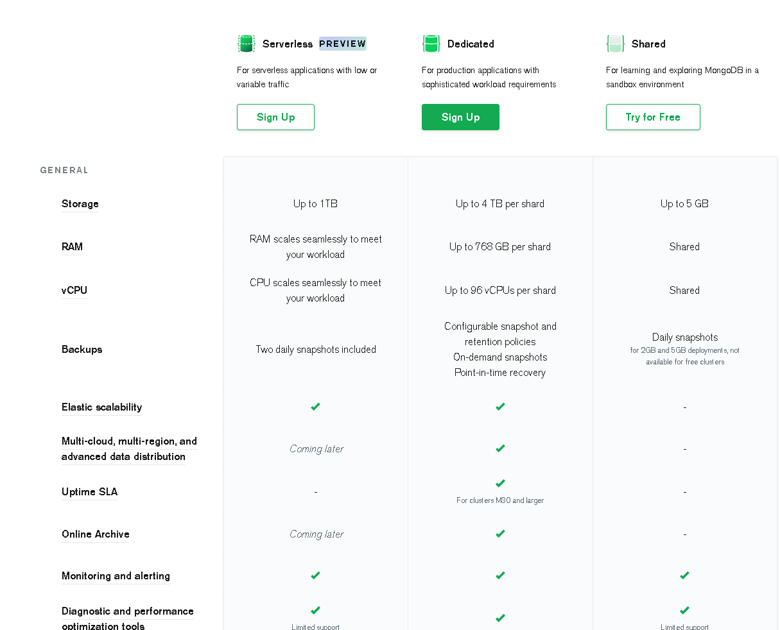

***Figure 4: Features for a dedicated cluster using MongoDB Atlas***

**Summary Table**

|  |  |  |  |  |  |  |
| --- | --- | --- | --- | --- | --- | --- |
|  | Year 0 | Year 1 | Year 2 | Year 3 | Year 4 | Year 5 |
| **Benefits** |  |  |  |  |  |  |
| Reduction of Office Supplies | N/A | $1,743.02 | $2,178.78 | $2,614.54 | $3,050.29 | $3,486.05 |
| Increase revenue by reducing time | N/A | $48,480.00 | $50,419.20 | $51,388.80 | $52,358.40 | $53,328.00 |
| **Development Costs** |  |  |  |  |  |  |
| Team | $22,890 | N/A | N/A | N/A | N/A | N/A |
| Client | $1,200 | N/A | N/A | N/A | N/A | N/A |
| Professor Detillier | $4,500 | N/A | N/A | N/A | N/A | N/A |
| Will Rubit | $225 | N/A | N/A | N/A | N/A | N/A |
| **Operational Costs** |  |  |  |  |  |  |
| Licenses | N/A | $1,425.19 | $1,480.19 | $1,480.19 | $1,480.19 | $1,480.19 |
| Equipment Upgrades | N/A | $1,007.67 | N/A | N/A | N/A | $949.99 |
| Maintenance | N/A | $360 | $360 | $360 | $360 | $360 |
| Enhancements | N/A | N/A | N/A | N/A | N/A | N/A |
| Printing Costs | N/A | $2,076.91 | $1,730.76 | $1,384.61 | $1,038.46 | $692.30 |
| Backup & Recovery | N/A | $0 | $0 | $0 | $0 | $0 |
| UH Discount | ($27,615) | N/A | N/A | N/A | N/A | N/A |
| **Total Cost** | **($1,200)** | **$45,353.25** | **$49,027.03** | **$50,378.18** | **$52,530.04** | **$53,331.57** |

**Risk and Risk Mitigation**

Risks are any events that could affect the project, either adversely or positively. Risk mitigation is the team's plan of action for reducing the impact of negative risks. Below is a discussion of Permanent Communications' risk management plan.

**Risk Management**

Permanent Communications utilized the following processes when managing risks:

1. Risk Identification:

The initial step of risk management involves identifying potential risks. Permanent Communications team members identified and described risks that the project could have faced.

1. Risk Categorization:

Once a risk event was identified, the Project Manager and Assistant Project Manager categorized the risk events based on their triggers (i.e., sponsor, team, technical and natural. For additional information regarding risk categories.

1. Risk Prioritization:

Once risk events were categorized, the Project Manager and Assistant Project Manager prioritized the risks based on the probability of the risk event occurring and the consequences the risk event would have should it occur. For additional information regarding risk prioritization.

**Risk Mitigation**

Permanent Communications utilized the following processes when mitigating risks:

1. Risk Trigger Identification:

The initial step of risk mitigation involves identifying the causes of a risk event. The Project Manager and Assistant Project Manager assessed risk events to identify the triggers that would cause the risks to occur.

1. Establish Risk Response:

Once a risk event's triggers were identified, the Project Manager and Assistant Project

Manager developed a plan to counteract the effects of the triggers.

All risks are documented in a risk register, where the risks are listed in order of priority. The risk register also contains the actions the team took to reduce the threat of the risk occurring.

The planning assumptions include a fifteen-table layout listing of all project expectations regarding the project team, sponsor, technical advisor, and UH Technical Support from the start of the project until the final delivery of the project. As described below, this listing has been validated by both the client and technical advisor upon final delivery. Furthermore, the foundation of these assumptions has not changed as a whole, but a few minor adjustments were necessary as the scope of the project changed mildly throughout the life of the project. All assumptions held true since the initial project plans except for these two listings: Project Production and Project Duration. Project Production was altered due to the mild modifications of the project scope, confirmed by the sponsor, and Project Duration changed due to the time crunch near the end of the project delivery process. Overall, the overall integrity of these assumptions held true throughout the entire life of the project

|  |  |  |  |  |  |
| --- | --- | --- | --- | --- | --- |
| ID | Description | Comments | Type | Status | Date Entered |
| 1 | Technical Software | The team will have all the necessary resources required to successfully deploy a functioning web app regarding technical software and online servers provided by the University of Houston, College of Technology. | Resources | Closed | 2/24/2022 |
| 2 | People | All five members of the Project team will dedicate valuable time to each other and maintain superior work ethic for the deployment of an excellent Application. Also, the project sponsor and technical advisor will be willing to collaborate/assist with any questions or concerns that may be present along the way. Also, Will Rubit and UH technical support will be available for any technical issues as well. | Resources | Closed | 2/24/2022 |
| 3 | Deployment | Deployment of project onto an online web service (via UH school server) that fully supports and confines our online application for internal use only regarding version 1.0. | Delivery | Closed | 2/24/2022 |
| 4 | Operating System Support | Online Web application arrives configured as expected where the client's operating system will have full access and be able to fully support all functionality within the app on a desktop/laptop. | Delivery | Closed | 2/24/2022 |
| ID | Description | Comments | Type | Status | Date Entered |
| 5 | Project Structure | The project team will follow a team assessed bottom-up approach regarding the initial outline of the overall structure, design, and blueprint of the online WBS web app. | Methodology | Closed | 2/24/2022 |
| 6 | Project Price Coverage | Project costs will stay within the range of coverage as agreed upon with the sponsor, any additional fees or over allocated prices will be dealt with or restructured by the project team. | Budget | Closed | 2/24/2022 |
| 7 | Project Cost | Any additional costs regarding technical software or servers outside of the University of Houston, College of Technology's coverage will be covered by our project manager at any point in time if ever deemed necessary. | Finances | Closed | 2/24/2022 |
| 8 | Project Scope | The project scope will not change or be altered once the sponsor signs off on the initial project scope statement as well as the technical advisor validates the project scope. | Scope | Closed | 2/24/2022 |
| 9 | Project Production | A well working and performing WBS will be deployed with complete CRUD functionality on an online platform for internal management use only by April 12, 2022. Also, a contact book of investors, subcontractors, and employees will be sustained for the sponsor. Finally, a listing of reports will be conveyed to each entity at its’ respected level. | Scope | Closed | 3/1/2022 |
| 10 | Project Duration | The timeline of the project deliverables will be followed strictly and closely by the project team as well as properly enforced by the project manager so that tasks and dependencies will be completed on time and in the appropriate order to further the validity and construction of our enterprise in a concise timely manner. | Schedule | Closed | 3/3/2022 |
| 11 | Programming Software | The online web-based application will be constructed using programming environment Visual Studio code using JavaScript. The backend database will be built and programmed with MongoDB. The frontend will be assembled with Vue along with Rest API routes. The testing environment used will be POSTMAN. And the statistical layout of the database data will be in JSON format. Final application deployment will be configured onto the online UH school server. | Technology | Closed | 2/24/2022 |
| ID | Description | Comments | Type | Status | Date Entered |
| 12 | Backbone Validation | The layout and overview of the backbone of the project has been validated and accepted by both the sponsor and technical advisor and will not be changed once agreed upon so that the product is delivered as the sponsor desires. | Architecture & Design | Closed | 2/25/2022 |
| 13 | Communication | Maintain effective communication between the sponsor, technical advisor, and all project team members so that everyone involved with the enterprise is always on the same page. | Quality | Closed | 2/25/2022 |
| 14 | Project Configuration | Deliverance and production of the internal web application will be deeply assessed, strongly configured, and well tested and debugged on the deployment of version 1.0 so that known errors or bugs will not be present during initial deliverance. | Quality | Closed | 2/25/2022 |
| 15 | Project Environment | Microsoft Teams and in-person collaborations at the University of Houston and Piping International's workspace will be the basis of networking between the sponsor, technical advisor, and all project team members. As the project progresses, these establishments of location will not change. | Location | Closed | 2/25/2022 |

**Project Constraints**

1. **Methodology**

Our methodology for identifying our project constraints was to have the team communicate with the project’s sponsor and other leading stakeholders. After meeting and identifying the sponsor’s needs and project’s requirements the team determined the project’s constraints as well as which constraints were flexible, and which were not. While the team identified several constraints, two team members were responsible for validating and recording constraints in the project’s documentation.

1. **Type**
2. **Scope**

The project’s scope was the team’s most flexible constraint. The minimum scope was a web application database for use by a business. Its features and functionality were at the team’s discretion. Over the course of the project, the project’s scope was changed many times to ensure that the project’s time constraint was met.

1. **Time**

Time was our least flexible constraint. While activities could be delayed, fast tracked, rescheduled, etc., the project had to have all activities completed by April 12th, 2022, 18:00 CST with no room for negotiation.

1. **Cost**

Cost was the constraint that the team was least affected by in terms of monetary assets, but most affected in terms of personnel. While the team was given little to no budget outside of a server provisioned by the University of Houston, the team felt no pressing need to spend capital on additional hardware or software. Having one less team member, however, meant that the five-member team was expected to perform the work of the standard six-member team, meaning each member had to take on 20% more work.

1. **Impact**

The team found the most impactful constraint to be the cost constraint, specifically having one less team member than other groups. By having one less team member compared to a standard group, each team member was required to perform more work. This led to the team deciding to reduce the project’s scope to meet their time constraints. If the team were given more time, a project of greater scope and more features could have been achieved. Additional capital was not necessary for this team, but an additional member would have had a significant impact on the project’s outcome. If present, work could have been rebalanced and enabled the team to push for a greater scope with the project.

**4. Constraint Documentation**

The project’s identified constraints were recorded in the following table:

|  |  |  |  |  |  |  |
| --- | --- | --- | --- | --- | --- | --- |
| **ID** |  | **Description** | **Comments** | **Type** | **Status** | **Date Entered** |
| 1 |  | Constraint: Limited time | The team only has until April 12th to complete and turn in all project materials. | Time | Closed | 2/21/2022 |
| 2 |  | Constraint: Budget | The sponsor has not provided the project with any capital or project dollars. | Cost | Closed | 2/21/2022 |
| 3 |  | Constraint: Team Members | The team is comprised of five members. Further limitation of personnel will have a negative impact on the project. | Cost | Closed | 2/21/2022 |
| 4 |  | Constraint: Software | The sponsor is unwilling to spend exorbitant resources for certain software, leading the team to rely upon freeware. | Cost | Closed | 2/21/2022 |
| 5 |  | Constraint: Database | Project must produce a database with CRUD functionality. | Scope | Closed | 2/24/2022 |
| 6 |  | Constraint: Web Application | Project will deliver a locally hosted web application. | Scope | Closed | 2/24/2022 |
| 7 |  | Constraint: Hardware | The web application will operate on a University of Houston provided server, rather than enterprise-level hardware. It will be limited by however much the University is willing to provide to the team. | Cost | Closed | 2/24/2022 |
| 8 |  | Constraint: Deployable Server | The web application must be able to be deployed on the University of Houston, College of Technology school server. | Scope | Closed | 3/04/2022 |

**Milestones**

Project milestones are tasks of zero duration that show an important achievement in a project. The milestones should represent a clear sequence of events that incrementally build up until your project is complete.

Project milestones are a way of knowing how the project is advancing, especially if you are not familiar with the tasks being executed. They have zero duration because they symbolize an achievement, or a point of time in a project. Since a milestone’s start and end date depends on a task’s start and end date, task association is a major feature of a milestone.

|  |  |
| --- | --- |
| **Milestones** | **Date** |
| First Team Meeting | February 1st, 2022 |
| Project Charter | February 15th, 2022 |
| Initial Project Plans | March 1st, 2022 |
| Spring Break | March 14th – March 19th, 2022 |
| Mid-Term Exam | March 22nd, 2022 |
| Complete Database Design | March 1st, 2022 |
| Completed Application Development | March 11th, 2022 |
| Completed Project Documentation | April 12th, 2022 |
| Final Projects Due | April 12th, 2022 |
| Group Presentations | April 12th – April 26th, 2022 |

**Gantt chart**

Project Gantt chart to highlight our start and end date of the project. It also includes our top-level tasks.

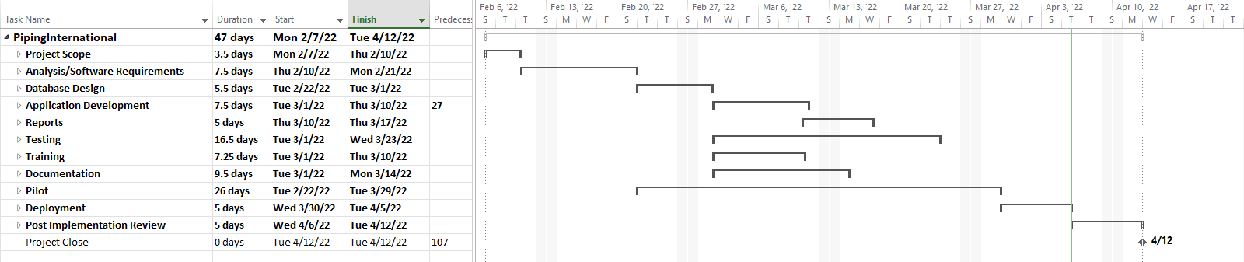

**Organization Chart**

The Organization Chart outlines the members of the overall project team including the project sponsor.

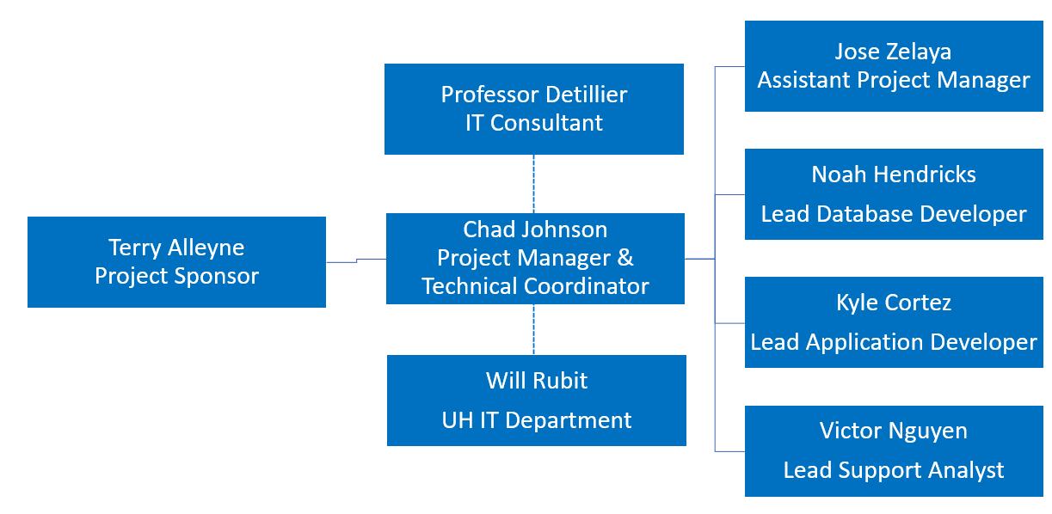

**Roles and Responsibilities Matrix**

| **Team Member** | **Primary Role** | **Secondary Role** | **Tertiary Role** |
| --- | --- | --- | --- |
| Chad Johnson | Project Manager:  Manages deliverable progress, overall project progress, and team cooperation. Plans and schedules weekly deliverable completion goals. | Meeting Facilitator:  Schedules meetings with the client and/or team members. Plans for flow of the meeting, prepares questions for the client, encourages team involvement, and helps lead the discussion. | Business Analyst:  Conducts research on the business client via surveys, interviews, questionnaires, and on-site visits. Understanding the workflow of systems implemented within the business and develops process models to direct the development team. |
| Jose Zelaya | Assistant Manager:  Assists the project manager with planning and scheduling of meetings, as well as reviewing progress on the deliverables. Helps in the assignment of deliverables to certain team members. | Systems Analyst:  Integrates functionality to system to improve business requirements. Contributing and maintaining the development of a new system design to help solve client’s problems by brainstorming, preparing, creating, and testing, | Support Developer:  Responsible for assisting developers’ work in various parts of the web app development, for example the backend or frontend. Conducting data validation as well as testing as development is conducted. |
| Kyle Cortez | Lead Application Developer:  Responsible for overlooking the design of the backend and frontend as well as ensuring that there is a style guide (CSS) being implemented in the web app. Also ensures that other developers are working on assigned work, as well as meeting with other developers to provide guidance and feedback on their contribution. | Systems Analyst:  Integrates functionality to system to improve business requirements. Contributing and maintaining the development of a new system design to help solve client’s problems by brainstorming, preparing, creating, and testing, | Tester:  Responsible for running the backend and frontend and running the Web Application. Ensuring that the intake forms or information that user inputs meets the data validation implemented in the backend and frontend if a problem arises make the needed changes if possible or inform other developers to assist. |
| Noah Hendricks | Lead Database Developer:  Responsible for creating the ERD then proceeding to create the data dictionary as well as helping developers understand the ERD. Also ensure that the data dictionary is updated and maintained as changes are made to the ERD as well as informing all team members of changes made. | Backend Developer:  Responsible for setting up the backend for Web Application creating the needed schemas that will reflect the collections or tables created in the ERD, as well as create the routes that are to conduct CRUD operations on the data being stored in the selected database type in this case of MongoDB a NoSQL DB. | Tester:  Responsible for running the backend and frontend then interacting with the created web pagers and ensuring that the information being inputted meets the data type validation conducted in the frontend and backend. |
| Victor Nguyen | Application Developer:  Works on developing Web Application conducted in the backend and frontend. Working with other developers to work on phases of the web application, for example an assigned web page that deals with subcontractors, etc. | Tester:  Responsible for conducting tests of the current working code in the backend as well as frontend. Testing is done on the routes that are being used as well as user input on the frontend to check for data validation. If there is a problem in terms of data validation, then inform the lead developer as well as other developers and work on a solution. | Support Analyst:  Responsible for assisting the database designer with the process creation of the ERD and data dictionary as well as reviewing the progress of other deliverables like the business case and requirements list, etc. |
| Terry Alleyne | Project Sponsor:  Responsible for the overall success of the project, including appointing the project manager and team, defining success criteria, and ensuring the successful delivery of the project. |  |  |
| Professor Detillier | IT Consultant:  Assist and educate, and a catalyst for deeper change, a resource, or a facilitator, the leadership of the process remains within your organization. |  |  |
| Will Rubit | IT Support Specialist:  Provide organizations with information technology support to optimize operational efficiency. Their duties include resolving technical issues, maintaining hardware and software installations, and improving IT systems. |  |  |

Microsoft Teams will be utilized to interact with all team members as well as check on each individual member’s respective progress on their assigned deliverables. Additionally, we will have scheduled meetings every week on Wednesdays at 2:30 pm to check each member's progress as well as have discussions over the deliverables as well address any problems that arise. And have a constructive discussion if problems do arise and find a mutual resolution if a conflict arises amongst group members. As well this method of communication will be used on other days of the week or weekends if needed to work on deliverables as well as the web application. Team members are responsible to notify team members if they cannot make a meeting on Wednesday at 2:30pm or on a scheduled meeting day. The method of notification will primarily be GroupMe or text message.

*GroupMe will be utilized to inform each other on due dates of deliverables or discuss over the deliverables. As well as keep constant communication on progress on deliverables as well as checking on each other whether we can schedule meetings. Also, if there is an emergency like someone gets sick or had a car accident, we are to inform through GroupMe primarily as that is the fastest way to communicate. Through GroupMe we will also conduct polls to check which days group members can meet in the week and at what time to ensure that everyone is able to attend the meeting. We are to maintain constant communication through GroupMe and make sure that everyone is focused on their respective tasks.

*Outlook will primarily be used to maintain communication with Professor Detillier regarding weekly status reports as well as inform him if an issue arises between team members. Additionally, if an emergency arises during the project the project manager is responsible for sending an email which all team members are part of the email through CC. Also, Outlook will need to be checked by all team members to make sure that we know when the project manager sends the weekly status report as well as when professor Detillier sends email.

**Communication Overview**

**Summary:** Create a project estimating web-based database application to support the Piping International client.

**Communication Goals:**

* Keep the project sponsor informed of project timeline, budget, and project needs
* Provide clear insight into any decisions needed or roadblocks
* Provide structured opportunities for feedback from the project sponsor
* Give the project sponsor the information needed to gain acceptance of the project

**Communication Types:**

* Daily check-ins
* Weekly status reports
* Major milestone meetings
* Daily group chats

**Communication Matrix**

|  |  |  |  |  |  |  |
| --- | --- | --- | --- | --- | --- | --- |
| **Communication** | **Method** | **Frequency** | **Location** | **Goal** | **Owner** | **Audience** |
| Client / Sponsor Meeting | Face to Face | As Needed | CIS Building 1 | Acquire information from client, review current project status, review deliverable progress, and receive client input | Project Manager | Permanent Communications Team & Project Sponsor |
| Consultant Meeting | Virtual Meeting | Weekly; Tuesday; 4:40PM-5:00PM | N/A | Review current project status along with feedback on deliverables and project progress | Project Manager | Permanent Communications Team |
| Team Meeting | Virtual Meeting | Weekly; Monday; 2:30PM-3:30PM | N/A | Review Deliverables, including Weekly Status report, as well as work on and discuss any pending deliverables | Project Manager | Permanent Communications Team |
| Team Meeting | Face to Face | Weekly; Tuesday; 9:00PM-9:15PM | Classroom | Review deliverables and cooperate to ensure that project and progress goals are being met | Project Manager | Permanent Communications Team |
| Team Meeting | Virtual Meeting | Weekly; Wednesday; 2:30PM-3:30PM | N/A | Review Deliverables, including Weekly Status report, as well as work on and discuss any pending deliverables | Project Manager | Permanent Communications Team |
| **Communication** | **Method** | **Frequency** | **Location** | **Goal** | **Owner** | **Audience** |
| Emergency Team Meeting | Meeting | As Needed | GroupMe / MS Teams | Discuss urgent problems or issues with any deliverables or project progress | Project Manager or Assistant Project Manager | Permanent Communications Team |
| Instant Messenger | GroupMe | Daily, As Needed | N/A | Share information with team and collaborate on project deliverables | Permanent Communications | Permanent Communications Team |
| Document Updates | MS Teams | Daily | N/A | Share and update documents for project deliverables | Permanent Communications | Permanent Communications Team |
| Team Email | Gmail / UH Mail / Hotmail | As Needed | N/A | Communication for entire team to receive emails from client | Permanent Communications | Permanent Communications Team & Project Sponsor |
| Progress Tracking | MS Project | Daily | N/A | Track Project Progress | Permanent Communications | Permanent Communications Team |

**Project Team Communication List**

| **Members** | **Role** | **Audience** | **Skillset** | **Method** | **Frequency** | **Email** |
| --- | --- | --- | --- | --- | --- | --- |
| Chad Johnson | Project Manager | Sponsor,  Project Team  Professor Detillier | Excel, Word, MS Project,  MS Visio | Teams,  GroupMe,  Outlook | 7 Times/ Week | [cjohns31@cougarnet.uh.edu](mailto:cjohns31@cougarnet.uh.edu) |
| Kyle Cortez | Lead Application Developer | Project Team  Professor Detillier | Excel, Word,  JavaScript,  MongoDB | Teams,  GroupMe,  Outlook | 5 times/ Week | [kjcorte2@cougarnet.uh.edu](mailto:kjcorte2@cougarnet.uh.edu) |
| Noah Hendricks | Lead Database Developer | Project Team  Professor Detillier | Excel, Word,  MS Visio,  JavaScript,  MongoDB | Teams,  GroupMe,  Outlook | 5 times/ Week | [njhendri@cougarnet.uh.edu](mailto:njhendri@cougarnet.uh.edu) |
| Victor Nguyen | Application Developer | Project Team  Professor Detillier | Excel, Word,  MS Visio,  JavaScript,  MongoDB | Teams,  GroupMe,  Outlook | 5 times/ Week | [vhnguy23@cougarnet.uh.edu](mailto:vhnguy23@cougarnet.uh.edu) |
| Jose Zelaya | Assistant Manager | Project Team  Professor Detillier | Excel, Word,  MS Visio,  JavaScript,  Java, MongoDB | Teams,  GroupMe,  Outlook | 6 Times/ Week | [jbzelaya@cougarnet.uh.edu](mailto:jbzelaya@cougarnet.uh.edu) |

**Elevator Speech**

1. What is the project about?

Piping international has issues with estimating project costs and project resources and asked Permanent Communication to create a project estimating web-based database application.

1. Why is the project important?

Piping has lost more than $40,000 on projects due to missing items when estimating

1. What does project success look like?

Completing the web-based application to meet the requirements of the project sponsor.

1. What that person can do to support or help the project.

Keep the project team informed on any issues or changes with the scope of the projects. Additionally, meet with the project team regularly.

**Project Pitch**

Terry Alleyne, Piping International business owner, accepted the proposal from Permanent Communications to create a project management system. Piping International is a fabrication company that also builds custom homes. Permanent Communications worked with Terry Alleyne during the information gathering process for the requirement to develop a new purpose-built application to manage the custom homes projects for Piping International. After several interviews and analyzing the data we gathered, we were about to understand the daily process of the business. With the information we gathered, we were able to present and project scope to Terry with the hopes he would approve the project.

Permanent Communications completed the analysis of the current business situation and developed a plan for a web-based application we called TAPI, Terry Alleyne Piping International. The name was created to highlight the owner and the company name. The system would be presented to Terry as a web-based, user interface, application with a MongoDB database on the backend. The application will allow for project creations, modifications, and closing, subcontractors contact information, as well as investors contact information.

The highpoint of creating the application is to reduce mistakes during project estimations and save subcontractor and investors information associated with the project. The system would also aim to increase the effectiveness for the core business processes of customer information tracking and acquiring repeat business with the investors. We expect $50,223 in benefits within the first year and anticipate the system growing to $56,814 in benefits by the end of the fifth year. Overall, Piping International would have a custom application that would add significant value to the success of Piping International business

**Quality Assurance**

**Responsibility:** Victor Nguyen

**Process:** Victor Nguyen is the primary person responsible for setting the standard for deliverables. All Permanent Communications members are expected to present their deliverables every Monday during our team meeting with the Quality Assurance Specialists taking extra care to consider potential changes such as: color correction, page formatting, and grammatical errors. If a deliverable does not meet the standard, it is to be returned to the author for correction. After the author has remedied the errors, they are to repeat the process at the next available team meeting or receive approval from a Quality Assurance Specialist. If the deliverable does meet the standard, it is applied to the appropriate category.

**Progress Control**

**Responsibility:** Chad Johnson | Jose Zelaya

**Process:** Progress control is to be managed by the Project Manager Chad Johnson, and Assistant Project Manager, Jose Zelaya. Every Monday during our team meeting, Chad Johnson reviews the project plan and advice the team on what is due the coming week.

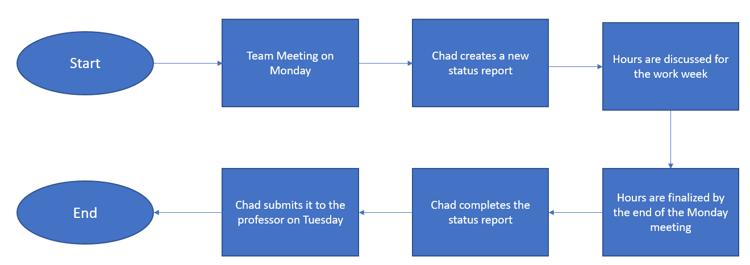

**Risk Control**

**Person of Responsibility:** Kyle Cortez

**Procedure:** If any member of the Permanent Communications project team encounters a risk or becomes aware of an unaccounted-for risk, they are to notify Kyle Cortez of the issue. After Kyle understands the risk, he logs the risk in the project risk matrix, then determines if the risk is worth escalating. If the risk needs to be escalated, it will be discussed in the next team meeting with the group leader and the project manager. If the issue is pressing, then he will consult with Chad Johnson the Project Manager to confirm a course of action.

**The following actions will all be taken:** The appropriate corrective and/or preventative action(s) will be enacted:

* The entire team is to be informed on GroupMe
* The risk matrix is to be updated, and the change log is to be updated
* If needed notify the Professor

**Issue Management**

Issue Management is the disciplined process of identifying, tracking, and resolving issues that affect a project’s progress and direction. Throughout a project’s life cycle, issues that affect the ability of the project team to meet project goals can occur on a regular basis. Issue Management is the set of procedures that help a project team manage issues. Issue Management interacts with Risk, Action Item, Communication, Quality, and Governance Management activities through the life cycle of a project effort.

PURPOSE: The purpose of the Issue Management Plan is to define how the project team will effectively identify, assess, and manage project issues as they emerge over the course of a project.

SCOPE: This Issue Management Plan is specific to the Permanent Communications project team. Project team members have a responsibility to identify project issues and comply with the Issue Management Process defined in this plan.

OBJECTIVES: The Piping International T.A.P.I. Web App project will take an integrated approach to manage issues from identification through to closure. The documentation of issue resolution is a critical aspect of this process given the lessons such resolutions can provide for future project releases or phases. The objective of this plan is to aggressively address and quickly resolve issues as they are raised throughout the project delivery timeline.

|  |  |  |  |  |  |  |  |
| --- | --- | --- | --- | --- | --- | --- | --- |
| **ID** | **Description** | **Priority** | **Date Opened** | **Date Closed** | **Issue Owner** | **Status** | **Notes** |
| 1 | Kyle tested positive for Covid | High | 11-Jan | 17-Jan | Kyle | Closed | No impact on the project timeline |
| 2 | 5 team members, not 6 like the other teams | Medium | 1-Feb |  | Chad | Open |  |
| 3 | The Application formatting looked different on different resolutions | Critical | 17-Mar | 21-Mar | Jose | Closed |  |
| 4 | Cannot get reports on a dashboard | Low | 22-Mar | 1-Apr | Kyle | Closed | Had to move forward without the dashboard |

**Problem Reporting**

Introduction

During the application development process, many problems were reported due to integration issues, functionality errors, and system crashes. It was important to log them in the exception and handling reports to ensure that a proper contingency plan could be formed to prevent these problems from happening again. This document helps to identify these problems and analyze the steps to find the correct solutions to these problems.

Problems Reported

Most of the problems the team reported were mostly over data validation between tables. Over the course of most of the GUI design steps, most of the workarounds were centered around making sure that the data tables displayed the correct format when taken and displayed by other tables on the website. Data integrity was key to ensuring that the problem was resolved through the different tables in MongoDB. Due to time constraints, reports were never added to the dashboard and pagination was never implemented to increase functionality in the application. It was decided later that it was better to let the application list these problems as future improvements falling back on the original table page.

Proposed Solutions

Some solutions that were proposed to solve the problems included simply not adding this feature or adding an alternative feature that can serve to satisfy the requirements needed to solve the problem such as turning numbers in the fields of tables into string to allow simple calculations to be made for the entire program itself.

Solution Analysis

By keeping most fields as string types, this makes calculation easier for our frontend since it will not be necessary to convert then calculation again when you can simply update the value depending on the new data provided.

Chosen Solutions

We have chosen for data validation to convert values into string and calculate its value from there to allow more smooth transition and display of these records into tables and intake forms. The reports on the dashboard will have its own separate tab in the navigation bar to ensure that it will still be reachable but will not be the first task you will see in the frontend.

Solution Impacts

The dashboard currently includes a slide gallery and a user manual to help users navigate through the website. Validation should still be functional without any problems in the overall data integrity of the entire application schema

**Change and Exception Handling**

Change Requests

Change requests and exception handling are about data validation within the application. When change requests are made, the developers must first identify the necessary improvement needed to complete that change then inform the project manager. In this project, we have done multiple change requests from adding intake forms to our website or including the slide gallery in the dashboard. Change requests must first be confirmed by the project manager for a change to be executed on the application. If the change cannot be made, then contingency plans must take effect to find a proper workaround in the scope of the project.

Exception Handling

Risk mitigation when identified by the team is recorded in the exception handling table. When a risk is discovered on the application, developers must first identify the source of the risk and discover its potential causes. Once the cause and effect of the risk is identified, the developers will have to produce a solution to ensure that the problem is either solved or a workaround is available. For the plan to be executed, the project manager and another member related to the problem will have to approve of this plan to make sure that no additional risks are created by the change in the application.

**Version (Configuration) Control**

Version control involves creating snapshots of application code during its development phase. These snapshots take a backup of the project during the time it was made and store it on GitHub. Our team has enabled version control through GitHub for every commit we make on our branches. This ensures that developers can always return to the previous iteration of the development process in case a problem arises that prevents the application from functioning correctly. Our GitHub repository currently has 2 branches to ensure that both developers can commit code to the servers without receiving merge conflicts, which is what happens when two developers commit code simultaneously and remove code from what was contained in previous commits in GitHub. The 1st branch is called the main branch since that is the application meant for presenting in class. The cloud branch is the application that adds MongoDB cloud database functionality and pagination to the table views in most of the web pages. These 2 branches have their own commits since they are both separate versions of the original code designed for the application.

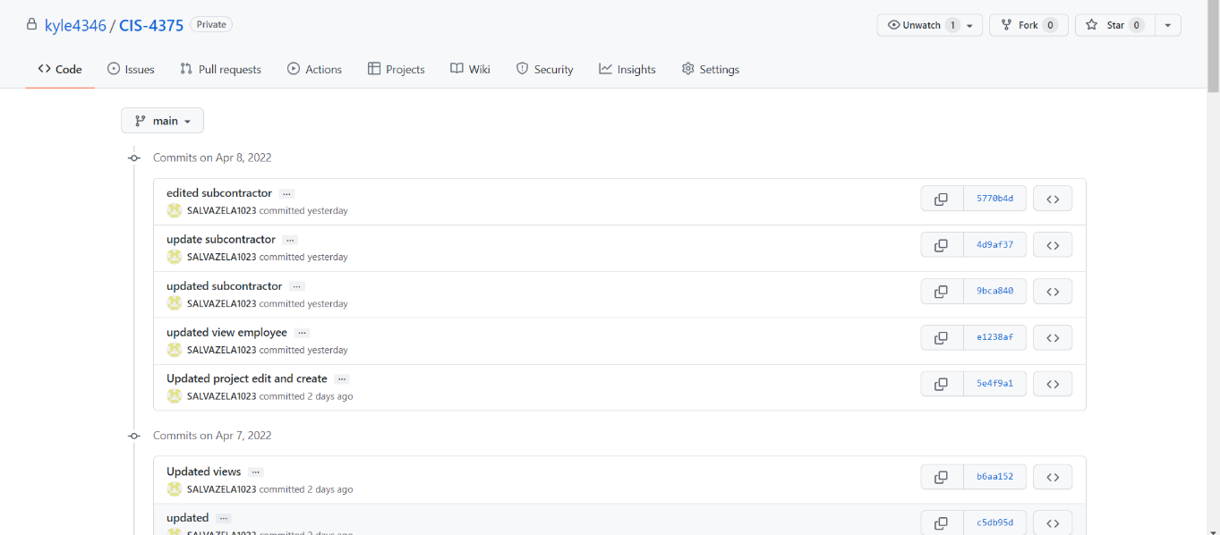

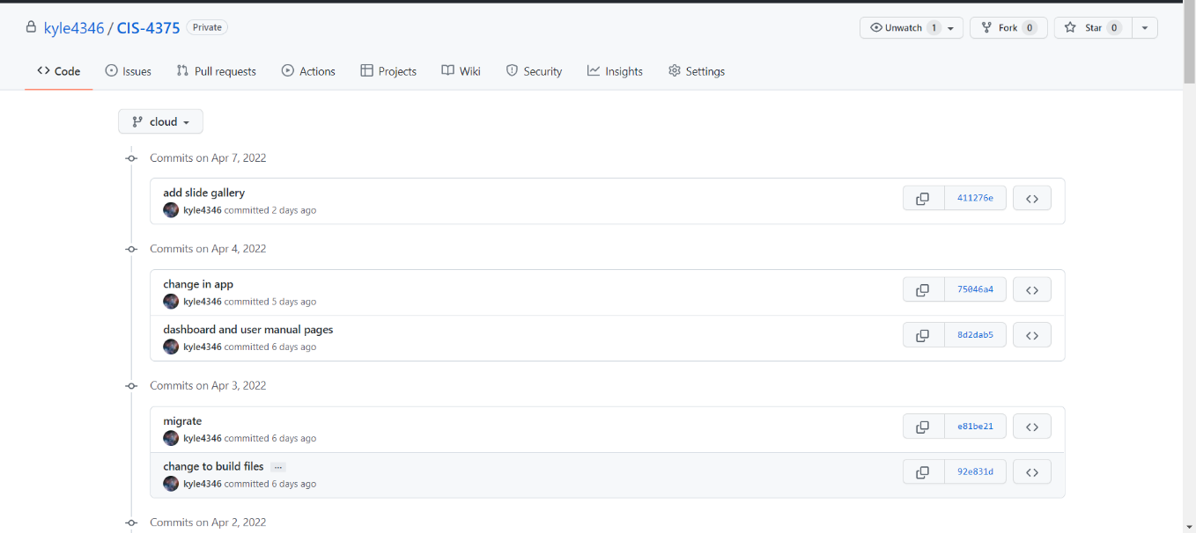

**Team Conflict Resolution**

**Internal**

The team had several control procedures for handling internal conflicts. Most conflicts within the team were minor in scale and informal. They mostly concerned disagreements over tasks, specifically how the team would display certain information and how to have the web application display reports. These minor conflicts were mostly resolved through compromise or reconciliation, usually verbally. These were usually beneficial to the team, as the alternative ideas generated by these conflicts led to a better product.

Major conflicts, such as decisions to discard or stop a given task were more contentious, as they usually resulted in delaying the progress of the project. These were usually associated with tasks related to requirements or the project constraints. We realized early in the project that cost and time were inflexible aside from schedule, while the most flexible was scope. This led to many conflicts over the project’s scope, as most major changes were related to that. Within the team, it was decided that the project manager would handle resolving major conflicts. If the project manager was unable to decide on a conflict, then he would bring it up with the sponsor, who had the final say on the project.

**External**

The team had few conflicts externally with stakeholders or the sponsor. The team decided that conflicts with the sponsor, if any, had to be resolved as quickly as possible. The project manager kept up constant communication with the sponsor to keep him informed of any developments and to ensure that any ideas he has can be realized, within the constraints of the project.

**Testing Strategy**

**Scope**

The people responsible for reviewing the testing strategy are the lead app developer and the project manager to ensure that the testing strategy is aligned with the project’s requirements. Now the approval of the testing strategy lies with the project manager, who will look over the testing strategy and ensure that all points are fulfilled or documented. The lead developer is responsible for writing the testing strategy. The backend was tested from the start of the development of the T.A.P.I. web application through Postman, which is a piece software that allows the user to check their routes that deal with the schemas that they created within the models. The timeframe of this testing was done from February 12, 2021, through April 10, 2021. This testing also applies to the frontend in which validation was incorporated in the following table’s employee, investor, subcontractor, project, phase, step, task, assigned investor, and assigned employee.

**Test Approach**

Process Testing:

When it comes to the process of testing the way that was done was by first doing incremental coding ensuring that at each phase of development there was incremental code being done. In the backend for example, the team started with creating the required schemas and once the employee schema was done, proceeded to create the employee model in the app.js file. The developer then proceeded to create the routes that reflected the CRUD operations create, read, update, and delete. Using the POST to create, GET to read, PUT to update, and delete to delete one data row. As the routes were finalized in the app.js file in the backend, the team then proceeded to create those routes in Postman, a piece of software that lets the user test their routes to see if the CRUD operations are functional. So, for each table that was created in the schemas folder, they were tested in Postman to ensure functionality. This same technique was applied to the aggregate pipeline routes that were created to conduct a join between two tables which was a GET route. That route was then created I the Postman and tested to ensure that through a matching field which is foreign key in both tables that would allow to pull data from both tables. Now before moving on to the front-end also mention that in the schemas folder where the employee table was created with its corresponding attributes. There was validation implemented to ensure that the first name field in the employee table would only allow string values and that it would have a min length of two characters and max length of twenty-five characters. Additionally, the first name was required, and a null value was not allowed for further validation. This was tested in Postman during the testing of the CRUD routes created in the app.js for the backend.

The testing approach in the front-end comprised of mostly working in the components folder which is where the intake forms are stored for the schemas created in the backend. These schemas are the following table’s employee, investor, subcontractor, project, phase, step, task, assigned employee, and assigned investor. So, the employee component is comprised of three files that are named create employee, edit employee, and view employee. Now this is the same idea in the creation of the other tables that was mentioned above; they all share the same three common verbs create, edit, and view. As the verbs imply in the create employee component is where one would create the intake form for employee which is linked to the backend post route to be able to create an employee. Now validation is done in that create employee component in the form of passing in the input field for a first name type text and then a min length two characters and twenty-five characters. Additionally, you will add a placeholder to let the user know what type of data he should be inserting in the input box. Also have a pattern that does further validation in the first name field like only allow lowercase or uppercase letter also add required to the input code. Now that same concept that is applied to a first name field in the create employee component is applied to all the fields that make up an employee table. Having that second layer of validation in the front end ensures that the user cannot input incorrect data and further enhances web application validation.

Testing levels:

Test levels are the same across the creation of the backend and frontend as a high level of testing in the backend that takes place to ensure that before even getting to the frontend there is some layer of validation and there are no errors in the backend code. Then in the frontend there is a high level of testing as at every part of a component there is already emplaced a code style guide implemented. This helps ensure that the create employee component has similar aspects to the create subcontractor in terms of having similar java script code. That is, using the put route to create an employee and the same get route to view an employee once an employee has been created. Then the view component for an employee has the same java script which is a get route that is tied to the backend to be able to view all the employees that have been created.

Types of Testing:

The primary type of testing that is conducted is data validation which is key to ensure that users in the front-end can only input, for example letters only for a first name or last name. Also, this validation testing is done throughout the SDLC of the web app. As data validation is done using Postman to ensure that a schema is fully functional like ensuring that the employee’s table attributes are correct in terms of type. Then the next type of testing is looking for errors in code in the form of improper data validation, for example in the edit web pages for an employee. A problem can be that in the create intake form there is working validation when inputting a first name or last name but when it comes to updating that employee the validation is not working. In that case, the problem would be in the frontend and backend for not having proper validation like doing (max Length) which is wrong spelling for validating a string value. The correct spelling is max length; if you do the other way you are not applying validation for the length of that string value instead for a number value which you will run into the problem of updating a field and being able to pass a thirty length first name which is wrong. So, the validation is case-sensitive so double checking the schemas in the backend and the components for all the tables was key to mitigate validation errors.

**Test Environment**

The test environment was primarily conducted on a laptop in which the data was stored locally on the machine had to ensure the developer had the MongoDB compass software to manage the local database and do quick alteration of data. That was conducted when testing massive number of entries of data and in the case that a field was deleted from the schema then that table had to be erased to mitigate any errors that could occur due to storing old data. So, every time there was a change in the backend a change was made in the frontend as well as the database which had to wipe the table’s old data. Also, all the web app testing was conducted using Google Chrome, as Mozilla Firefox was not app friendly when it came to bootstrap version 3, particularly the intake forms. That is why most of the testing when designing the layout of the intake forms and adding radio buttons or dropdown lists were primarily being evaluated on Chrome.

**Testing Tools**

The testing tools were primarily three pieces of software programs which are Postman, MS Visual Studio, and MongoDB Compass. Postman was used to validate every route created in the backend and to ensure that the validation conducted in the schemas that represented the tables in the ERD and data dictionary attributes were correctly being inputted when running a post route. MS Visual Studio is the primary program, which was used to program using the following languages, HTML, CSS, JavaScript, and Vue.JS. As well as understanding a CSV file and how to write it out when it comes to creating the routes in Postman and passing the fields from the tables. Visual Studio helped in showing the console when errors occurred, as there was error exception handling conducted on all facets of the backend and frontend. For example, the error exception handling was followed by a print to console code that would produce a message that stated investor successfully created, or investor was deleted. Also, when an error occurred in the console it would display the error, for example the user passed thirty characters for first name which should have been max twenty-five characters. In the console in the MS Visual Studio, it will produce a message that says max length is 25 but provided 30 something similar. MongoDB Compass was key in setting up the database and being able to quickly manage the database and make any necessary changes like dropping a table or deleting all the data in it as well as debugging errors on the table that were created. For example, in the index their old values being tracked that were recently removed from the table like removing an unnecessary id value. So, in MongoDB Compass the user can remove old unique attributes that are no longer part of the schema in the backend to fix a creation error when it displays an attribute that you recently removed.

**Project Summary**

Terry Alleyne, Piping International business owner, accepted the proposal from Permanent Communications to create a project management system. Piping International is a fabrication company that also builds custom homes. Permanent Communications worked with Terry Alleyne during the information gathering process for the requirement to develop a new purpose-built application to manage the custom homes projects for Piping International. After several interviews and analyzing the data we gathered, we were about to understand the daily process of the business. With the information we gathered, we were able to present and project scope to Terry with the hopes he would approve the project.

Permanent Communications completed an analysis of the current business situation and developed a plan for a web-based application we called T.A.P.I., Terry Alleyne Piping International. The name was created to highlight the owner and the company name. The system would be presented to Terry as a web-based, user interface, application with a MongoDB database on the backend. The application will allow for project creation, modification, closing, managing subcontractor contact information, as well as investors contact information.

The highpoint of creating the application was reducing mistakes during project estimations and saving subcontractor and investor’s information associated with the project. The system would also aim to increase the effectiveness of the core business processes of customer information tracking and acquiring repeat business with the investors. We expect $50,223 in benefits within the first year and anticipate the system growing to $56,814 in benefits by the end of the fifth year. Overall, Piping International will have a custom application that would add significant value to the success of Piping International’s business.

|  |  |
| --- | --- |
| PROJECT TITLE | DATE OF REPORT |
| T.A.P.I. 1.0 Web Application | 04/07/2022 |
| TEAM MEMBERS | PROJECT MANAGER |
| Jose Zelaya | Noah Hendricks | Kyle Cortez | Victor Nguyen | Chad Johnson |

**Top Three Lessons Learned with Recommendations for Future Projects**

1. **Double the Estimated Project Length.**

Programming takes longer than expected if you want it done correctly. The team had an extremely small window with limited resources to complete the project in less than three months. We should have estimated 8 months to complete the T.A.P.I. project.

1. **Better Done Than Perfect**

We had an aggressive timeline to complete the project as well as ensure the other class assignments were complete. We set our sights on completing the application even though it could have looked better. The next time we undertake a project of this scope, we should spend more time on the optics and style of the application.

1. **Ask For Help!**

We ran into several moments where deliverables were due but decided to push through rather than ask for help. The next time we undertake a project of this scope, we will engage industry professionals to assist with the planning, development, and implementation of a new application.

|  |
| --- |
| **What unexpected events helped to get this project done (i.e., a particularly good technical resource, unexpectedly easy install, etc.)? Where was significant time saved as a result?** |
| * Jose had professor Detillier in a previous class which allowed us to have an idea of the professor’s assignment expectation. * Jose, Kyle, and Noah were great technical resources for the project. * Victor’s pessimistic viewpoint of the project. His way of thinking and suggestions were allowed for a great resource. * The project sponsor visiting Chad’s house for a TEAMS meeting to demo the application for him. |

|  |
| --- |
| **Considering the top four or five “usual suspects” (i.e., short timeline, miscommunication, lack of technical knowledge, etc.), to what extent did this project suffer from these?** |
| * A short timeline crippled our team, especially with our limited team size. Every moment was overdrive. * Our lack of knowledge forced us to tell the sponsor no on a few requests. For example, building a dashboard. |

|  |
| --- |
| **Has there been a project like this one in the past? If so, did we benefit from the Lessons Learned from that project? Which problems did we avoid, and which did we repeat? Which knowledge and experiences from this project can we pass on to others?** |
| * We did not have a previous project of this scope to reference. |
| **How was the communication between the team members?** |
| * We had excellent communication with the team members. We spent countless hours discussing the project. * We had weekly meetings. |

|  |
| --- |
| **How can future planning and organization be improved to better meet project timelines and objectives?** |
| * Project scope explanation and funding sources with better technical knowledge of application product. * Be sure to have a clear-cut scope definition. * Try to minimize scope changes during project executions phase. |

|  |
| --- |
| **What are the three most important lessons we learned on this project that we can pass on to future project teams?** |
| Chad Johnson, Project Manager   * I realize I cannot please everyone, and that is OK. * I must trust in myself, that I will be able to bring my vision to life. * I learn to manage my own expectations. |

<https://www.amazon.com/Mead-Spiral-Notebook-Subject-Assorted/dp/B00QARECSS/ref=sr_1_7?crid=3KDN902EHQ5FF&keywords=notebooks+pack+of+12&qid=1649470871&sprefix=notebooks+pack+of+12%2Caps%2C97&sr=8-7>

<https://www.amazon.com/Post-Sticking-Janeiro-Collection-654-24SSAU-CP/dp/B00CMKA9HK/ref=sxin_15?asc_contentid=amzn1.osa.69d286a5-40df-4796-ae63-29add0e3f290.ATVPDKIKX0DER.en_US&asc_contenttype=article&ascsubtag=amzn1.osa.69d286a5-40df-4796-ae63-29add0e3f290.ATVPDKIKX0DER.en_US&creativeASIN=B00CMKA9HK&crid=1O97VZNQR1NK6&cv_ct_cx=sticky%2Bnotes&cv_ct_id=amzn1.osa.69d286a5-40df-4796-ae63-29add0e3f290.ATVPDKIKX0DER.en_US&cv_ct_pg=search&cv_ct_we=asin&cv_ct_wn=osp-single-source-earns-comm&keywords=sticky%2Bnotes&linkCode=oas&pd_rd_i=B00CMKA9HK&pd_rd_r=eb086751-6598-4528-a0f4-16593aad8262&pd_rd_w=90tfi&pd_rd_wg=9HZDA&pf_rd_p=164f02eb-e971-490d-8f4e-fba29be780ad&pf_rd_r=1N13A1QY9FBJ91K8C6AC&qid=1649471263&sprefix=sticky%2Bnotes%2Caps%2C114&sr=1-1-a3cc9a7a-2f07-46dc-8259-ac02200376a0&tag=ftl_os-20&th=1>

<https://www.amazon.com/BIC-Ecolutions-Ballpoint-Medium-50-Count/dp/B00CLHE47A/ref=sr_1_1?crid=13MFRX23445JK&keywords=pens+pack+of+50&qid=1649471432&s=office-products&sprefix=pens+pack+of+50%2Coffice-products%2C87&sr=1-1>

<https://www.officedepot.com/a/products/4981958/Brother-HL-L3270CDW-Wireless-Color-Laser/>

<https://www.brother-usa.com/products/hll3270cdw#accessories>

<https://www.amazon.com/Hammermill-Printer-Paper-Copy-8-5/dp/B06XRMJPJC/ref=sxin_16?asc_contentid=amzn1.osa.540a04e7-f295-45e5-9342-d4bc94f385ba.ATVPDKIKX0DER.en_US&asc_contenttype=article&ascsubtag=amzn1.osa.540a04e7-f295-45e5-9342-d4bc94f385ba.ATVPDKIKX0DER.en_US&creativeASIN=B06XRMJPJC&crid=2F48J5YIHSMG7&cv_ct_cx=legal+paper&cv_ct_id=amzn1.osa.540a04e7-f295-45e5-9342-d4bc94f385ba.ATVPDKIKX0DER.en_US&cv_ct_pg=search&cv_ct_we=asin&cv_ct_wn=osp-single-source-earns-comm&keywords=legal+paper&linkCode=oas&pd_rd_i=B06XRMJPJC&pd_rd_r=f8e4bf6c-aebc-4c88-81b2-f8f62e622d22&pd_rd_w=pWUgG&pd_rd_wg=o0hSo&pf_rd_p=164f02eb-e971-490d-8f4e-fba29be780ad&pf_rd_r=HBJT48YWWY3609G2QHF5&qid=1649472483&sprefix=legal+paper%2Caps%2C110&sr=1-2-a3cc9a7a-2f07-46dc-8259-ac02200376a0&tag=geekcontent-20>

https://www.microcenter.com/product/611527/inland-wm56-wireless-notebook-mouse-black

https://www.microcenter.com/product/647524/lenovo-ideapad-5i-156-laptop-computer-blue

<https://www.amazon.com/LG-32ML600M-B-Inch-Full-Monitor/dp/B07PDHSVSW/ref=sr_1_3?crid=3HRX63U97VPTE&keywords=monitor+32+inch&qid=1649475171&sprefix=monitor+32%2Caps%2C107&sr=8-3>

<https://www.amazon.com/Passport-Portable-External-Drive-Black/dp/B07VTWX8MN/ref=sr_1_6?crid=2U1ZU0GTVGRFH&keywords=external%2Bhard%2Bdrive&qid=1649475770&sprefix=external%2Bhard%2Bdrive%2Caps%2C100&sr=8-6&th=1>

https://www.microcenter.com/product/642148/micro-center-512gb-superspeed-usb-31-(gen-1)-flash-drive

[MongoDB Atlas | Multi-cloud Application Data Platform | MongoDB](https://www.mongodb.com/atlas)

[Pricing | MongoDB](https://www.mongodb.com/pricing)

[Norton 360 Deluxe | $55 off for the First Year of Subscription](https://us.norton.com/products/norton-360-deluxe?inid=nortoncom_nav_norton-360-deluxe_products-services:norton-360-lifelock-ultimate-plus)

[Norton 360 with LifeLock 25% off Promo | Norton LifeLock Combined at LifeLockPartner.com](https://lifelockpartner.com/norton-360-with-lifelock/)

**Work Breakdown Structure**

|  |  |  |  |  |  |  |
| --- | --- | --- | --- | --- | --- | --- |
| Task Name | Duration | Start | Finish | Predecessors | Resource Names | Actual Work |
| **Piping International** | **45 days** | **Mon 2/7/22** | **Fri 4/8/22** |  |  | **216 hrs.** |
| **Project Scope** | **3.5 days** | **Mon 2/7/22** | **Thu 2/10/22** |  |  | **20 hrs.** |
| Determine project scope | 0.5 days | Mon 2/7/22 | Mon 2/7/22 |  | Terry Alleyne | 4 hrs. |
| Secure project sponsorship | 0.5 days | Mon 2/7/22 | Mon 2/7/22 | 2 | Terry Alleyne | 4 hrs. |
| Define preliminary resources | 1 day | Tue 2/8/22 | Wed 2/9/22 | 3 | Chad Johnson | 8 hrs. |
| Secure core resources | 0.5 days | Wed 2/9/22 | Wed 2/9/22 | 4 | Chad Johnson | 4 hrs. |
| Scope complete | 0 days | Thu 2/10/22 | Thu 2/10/22 | 5 | Chad Johnson | 0 hrs. |
| **Analysis/Software Requirements** | **7.5 days** | **Thu 2/10/22** | **Mon 2/21/22** |  |  | **68 hrs.** |
| Conduct needs analysis | 0.5 days | Thu 2/10/22 | Thu 2/10/22 | 6 | Jose Zelaya | 4 hrs. |
| Draft preliminary software specifications | 1 day | Fri 2/11/22 | Fri 2/11/22 | 8 | Victor Nguyen | 8 hrs. |
| Develop preliminary budget | 1 day | Mon 2/14/22 | Mon 2/14/22 | 9 | Kyle Cortez | 8 hrs. |
| Review software specifications/budget with team | 1 day | Tue 2/15/22 | Tue 2/15/22 | 10 | Kyle Cortez | 8 hrs. |
| Incorporate feedback on software specifications | 1 day | Wed 2/16/22 | Wed 2/16/22 | 11 | Victor Nguyen | 8 hrs. |
| Develop delivery timeline | 1 day | Thu 2/17/22 | Thu 2/17/22 | 12 | Chad Johnson | 8 hrs. |
| Obtain approvals to proceed (concept, timeline, budget) | 1 day | Fri 2/18/22 | Fri 2/18/22 | 13 | Chad Johnson, Terry Alleyne | 16 hrs. |
| Secure required resources | 1 day | Mon 2/21/22 | Mon 2/21/22 | 14 | Chad Johnson | 8 hrs. |
| Analysis complete | 0 days | Mon 2/21/22 | Mon 2/21/22 | 15 |  | 0 hrs. |
| **Database Design** | **5.5 days** | **Tue 2/22/22** | **Tue 3/1/22** |  |  | **60 hrs.** |
| Determine entities | 1 day | Tue 2/22/22 | Tue 2/22/22 | 16 | Chad Johnson | 8 hrs. |
| Define entities and attributes | 1 day | Wed 2/23/22 | Wed 2/23/22 | 18 | Noah Hendricks | 8 hrs. |
| Draft ERD | 1 day | Thu 2/24/22 | Thu 2/24/22 | 19 | Noah Hendricks | 8 hrs. |
| Compare ERD with Business Rules | 1 day | Fri 2/25/22 | Fri 2/25/22 | 20 | Noah Hendricks | 8 hrs. |
| Normalize ERD | 1 day | Mon 2/28/22 | Mon 2/28/22 | 21 |  | 0 hrs. |
| Create Data dictionary | 1 day | Thu 2/24/22 | Thu 2/24/22 | 22 | Noah Hendricks | 8 hrs. |
| Incorporate feedback into functional specifications | 1 day | Fri 2/25/22 | Fri 2/25/22 | 23 | Chad Johnson | 8 hrs. |
| Task Name | Duration | Start | Finish | Predecessors | Resource Names | Actual Work |
| Approve Data Dictionary + ERD | 1 day | Mon 2/28/22 | Mon 2/28/22 | 24 | Chad Johnson | 8 hrs. |
| Obtain approval to proceed | 0.5 days | Tue 3/1/22 | Tue 3/1/22 | 25 | Prof. Detillier | 4 hrs. |
| Design complete | 0 days | Tue 3/1/22 | Tue 3/1/22 | 26 |  | 0 hrs. |
| **Application Development** | **9 days** | **Tue 3/1/22** | **Mon 3/14/22** |  |  | **28 hrs.** |
| **Application Design** | **3 days** | **Tue 3/1/22** | **Fri 3/4/22** | **27** |  | **0 hrs.** |
| Create high level application workflow | 1 day | Tue 3/1/22 | Wed 3/2/22 |  | Chad Johnson | 0 hrs. |
| Identify what information goes on each page | 1 day | Wed 3/2/22 | Thu 3/3/22 | 30 | Chad Johnson | 0 hrs. |
| Identify functions | 1 day | Thu 3/3/22 | Fri 3/4/22 | 31 | Chad Johnson | 0 hrs. |
| **GUI Design** | **1 day** | **Fri 3/4/22** | **Mon 3/7/22** | **32** |  | **0 hrs.** |
| Design layout of pages/forms | 1 day | Fri 3/4/22 | Mon 3/7/22 |  | Jose Zelaya | 0 hrs. |
| Break apart layout of pages | 1 day | Fri 3/4/22 | Mon 3/7/22 |  | Victor Nguyen | 0 hrs. |
| Write code for forms | 1 day | Fri 3/4/22 | Mon 3/7/22 |  | Jose Zelaya, Victor Nguyen | 0 hrs. |
| **Coding** | **7 days** | **Tue 3/1/22** | **Wed 3/7/22** |  |  | **0 hrs.** |
| Code pages of forms in HTML | 1 day | Tue 3/1/22 | Wed 3/2/22 | 26 | Noah Hendricks | 0 hrs. |
| Write queries for pages | 1 day | Tue 3/1/22 | Wed 3/2/22 |  | Jose Zelaya | 0 hrs. |
| Code the functions | 1 day | Tue 3/1/22 | Wed 3/2/22 |  | Kyle Cortez | 0 hrs. |
| Review code for security issues | 1 day | Tue 3/1/22 | Wed 3/2/22 |  | Kyle Cortez | 0 hrs. |
| Review functional specifications | 0.5 days | Tue 3/1/22 | Tue 3/1/22 | 34 | Chad Johnson | 4 hrs. |
| Identify modular/tiered design parameters | 2 days | Wed 3/2/22 | Thu 3/3/22 | 42 | Chad Johnson | 16 hrs. |
| Assign development staff | 1 day | Fri 3/4/22 | Fri 3/4/22 | 43 | Chad Johnson | 8 hrs. |
| Develop code | 5 days | Mon 3/7/22 | Fri 3/11/22 | 44 | Kyle Cortez, Noah Hendricks | 0 hrs. |
| Developer testing (primary debugging) | 2 days | Tue 3/8/22 | Thu 3/10/22 | 45FS-75% | Victor Nguyen | 0 hrs. |
| Development complete | 0 days | Thu 3/10/22 | Thu 3/10/22 | 46 | Chad Johnson | 0 hrs. |
| **Reports** | **5 days** | **Thu 3/10/22** | **Thu 3/17/22** |  |  | **0 hrs.** |
| Identify what reports to add to the application | 1 day | Thu 3/10/22 | Fri 3/11/22 | 46 | Victor Nguyen | 0 hrs. |
| Verify reports satisfy user requirements | 1 day | Fri 3/11/22 | Mon 3/14/22 | 49 | Victor Nguyen | 0 hrs. |
| Write queries for reports | 1 day | Mon 3/14/22 | Tue 3/15/22 | 50 | Noah Hendricks | 0 hrs. |
| Task Name | Duration | Start | Finish | Predecessors | Resource Names | Actual Work |
| Write code for reports | 1 day | Tue 3/15/22 | Wed 3/16/22 | 51 | Victor Nguyen | 0 hrs. |
| Sponsors approval of application | 1 day | Wed 3/16/22 | Thu 3/17/22 | 52 | Terry Alleyne | 0 hrs. |
| **Testing** | **16.5 days** | **Tue 3/1/22** | **Wed 3/23/22** |  |  | **8 hrs.** |
| Develop unit test plans using product specifications | 1 day | Tue 3/1/22 | Wed 3/2/22 | 27 | Victor Nguyen | 8 hrs. |
| Develop integration test plans using product specifications | 1 day | Tue 3/1/22 | Wed 3/2/22 | 27 | Noah Hendricks | 0 hrs. |
| **Unit Testing** | **5 days** | **Mon 3/14/22** | **Fri 3/18/22** |  |  | **0 hrs.** |
| Review modular code | 1 day | Mon 3/14/22 | Mon 3/14/22 | 55,47 | Kyle Cortez | 0 hrs. |
| Test component modules to product specifications | 1 day | Tue 3/15/22 | Tue 3/15/22 | 47,58 | Noah Hendricks | 0 hrs. |
| Identify anomalies to product specifications | 1 day | Wed 3/16/22 | Wed 3/16/22 | 59 | Noah Hendricks | 0 hrs. |
| Modify code | 1 day | Thu 3/17/22 | Thu 3/17/22 | 60 | Kyle Cortez | 0 hrs. |
| Re-test modified code | 1 day | Fri 3/18/22 | Fri 3/18/22 | 61 | Noah Hendricks | 0 hrs. |
| Unit testing complete | 0 days | Fri 3/18/22 | Fri 3/18/22 | 62 | Noah Hendricks | 0 hrs. |
| **Integration Testing** | **3 days** | **Mon 3/21/22** | **Wed 3/23/22** |  | **Kyle Cortez** | **0 hrs.** |
| Test module integration | 1 day | Mon 3/21/22 | Mon 3/21/22 | 63 | Victor Nguyen | 0 hrs. |
| Identify anomalies to specifications | 0 days | Mon 3/21/22 | Mon 3/21/22 | 65 | Jose Zelaya | 0 hrs. |
| Modify code | 1 day | Tue 3/22/22 | Tue 3/22/22 | 66 | Kyle Cortez | 0 hrs. |
| Re-test modified code | 1 day | Wed 3/23/22 | Wed 3/23/22 | 67 | Noah Hendricks | 0 hrs. |
| Integration testing complete | 0 days | Wed 3/23/22 | Wed 3/23/22 | 68 |  | 0 hrs. |
| **Training** | **10.75 days** | **Tue 3/1/22** | **Wed 3/16/22** |  |  | **8 hrs.** |
| Develop training specifications for end users | 1 day | Tue 3/1/22 | Wed 3/2/22 | 27 | Victor Nguyen | 8 hrs. |
| Develop training specifications for helpdesk support staff | 1 day | Tue 3/1/22 | Wed 3/2/22 | 27 | Victor Nguyen | 0 hrs. |
| Identify training delivery methodology (computer-based training, classroom, etc.) | 1 day | Tue 3/1/22 | Wed 3/2/22 | 27 | Victor Nguyen | 0 hrs. |
| Develop training materials | 1 day | Thu 3/10/22 | Fri 3/11/22 | 71,47,72,73 | Victor Nguyen | 0 hrs. |
| Conduct training usability study | 1 day | Fri 3/11/22 | Mon 3/14/22 | 74 | Victor Nguyen | 0 hrs. |
| Finalize training materials | 1 day | Mon 3/14/22 | Tue 3/15/22 | 75 | Victor Nguyen | 0 hrs. |
| Develop training delivery mechanisms | 1 day | Tue 3/15/22 | Wed 3/16/22 | 76 | Victor Nguyen | 0 hrs. |
| Task Name | Duration | Start | Finish | Predecessors | Resource Names | Actual Work |
| Training materials complete | 0 days | Wed 3/16/22 | Wed 3/16/22 | 77 |  | 0 hrs. |
| **Documentation** | **13 days** | **Tue 3/1/22** | **Fri 3/18/22** |  |  | **8 hrs.** |
| Develop Help specification | 1 day | Tue 3/1/22 | Wed 3/2/22 | 27 | Jose Zelaya | 8 hrs. |
| Develop Help system | 2 days | Wed 3/9/22 | Fri 3/11/22 | 80,45FS-50% | Kyle Cortez | 0 hrs. |
| Review Help documentation | 3 days | Fri 3/11/22 | Wed 3/16/22 | 81 | Jose Zelaya | 0 hrs. |
| Incorporate Help documentation feedback | 2 days | Wed 3/16/22 | Fri 3/18/22 | 82 | Jose Zelaya | 0 hrs. |
| Develop user manuals specifications | 2 days | Tue 3/1/22 | Thu 3/3/22 | 27 | Jose Zelaya | 0 hrs. |
| Develop user manuals | 2 days | Wed 3/9/22 | Fri 3/11/22 | 84,45FS-50% | Jose Zelaya | 0 hrs. |
| Review all user documentation | 2 days | Fri 3/11/22 | Tue 3/15/22 | 85 | Jose Zelaya | 0 hrs. |
| Incorporate user documentation feedback | 2 days | Tue 3/15/22 | Thu 3/17/22 | 86 | Jose Zelaya | 0 hrs. |
| Documentation complete | 0 days | Fri 3/18/22 | Fri 3/18/22 | 87,83 |  | 0 hrs. |
| **Pilot** | **26 days** | **Tue 2/22/22** | **Tue 3/29/22** |  |  | **16 hrs.** |
| Identify test group | 1 day | Tue 2/22/22 | Tue 2/22/22 | 16 | Chad Johnson | 8 hrs. |
| Develop software delivery mechanism | 1 day | Wed 2/23/22 | Wed 2/23/22 | 90 | Kyle Cortez | 8 hrs. |
| Install/deploy software | 1 day | Thu 3/24/22 | Thu 3/24/22 | 69,91,88,78 | Victor Nguyen | 0 hrs. |
| Obtain user feedback | 2 days | Fri 3/25/22 | Mon 3/28/22 | 92 | Chad Johnson | 0 hrs. |
| Evaluate testing information | 1 day | Tue 3/29/22 | Tue 3/29/22 | 93 | Kyle Cortez, Noah Hendricks | 0 hrs. |
| Pilot complete | 0 days | Tue 3/29/22 | Tue 3/29/22 | 94 |  | 0 hrs. |
| **Deployment** | **5 days** | **Wed 3/30/22** | **Tue 4/5/22** |  |  | **0 hrs.** |
| Determine final deployment strategy | 1 day | Wed 3/30/22 | Wed 3/30/22 | 95 | Jose Zelaya | 0 hrs. |
| Develop deployment methodology | 1 day | Thu 3/31/22 | Thu 3/31/22 | 97 | Jose Zelaya | 0 hrs. |
| Secure deployment resources | 1 day | Fri 4/1/22 | Fri 4/1/22 | 98 | Chad Johnson | 0 hrs. |
| Train support staff | 1 day | Mon 4/4/22 | Mon 4/4/22 | 99 | Kyle Cortez, Noah Hendricks | 0 hrs. |
| Deploy software | 1 day | Tue 4/5/22 | Tue 4/5/22 | 100 | Victor Nguyen | 0 hrs. |
| Deployment complete | 0 days | Tue 4/5/22 | Tue 4/5/22 | 101 |  | 0 hrs. |
| **Post Implementation Review** | **3 days** | **Wed 4/6/22** | **Fri 4/8/22** |  |  | **0 hrs.** |
| Document lessons learned | 1 day | Wed 4/6/22 | Wed 4/6/22 | 102 | Chad Johnson | 0 hrs. |
| Task Name | Duration | Start | Finish | Predecessors | Resource Names | Actual Work |
| Distribute to team members | 1 day | Thu 4/7/22 | Thu 4/7/22 | 104 | Chad Johnson | 0 hrs. |
| Create software maintenance team | 1 day | Fri 4/8/22 | Fri 4/8/22 | 105 | Chad Johnson | 0 hrs. |
| Post implementations review complete | 0 days | Fri 4/8/22 | Fri 4/8/22 | 106 |  | 0 hrs. |
| Project Close | 0 days | Tue 4/12/22 | Tue 4/12/22 | 107 |  | 0 hrs. |

**PERT Chart**

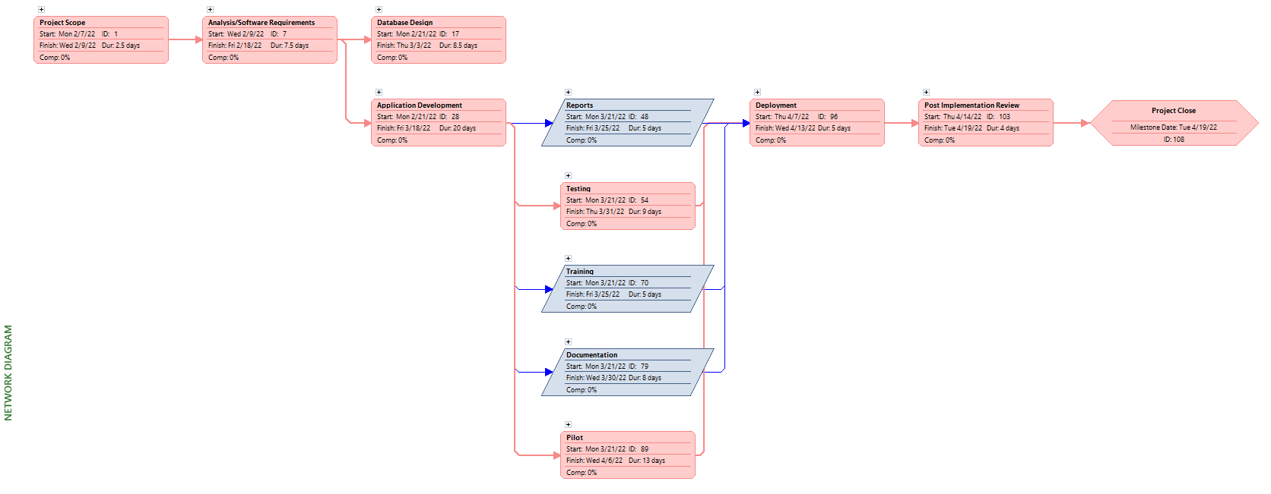

**Detailed Problems & Requirements List**

|  |  |  |  |  |  |  |  |  |  |  |  |
| --- | --- | --- | --- | --- | --- | --- | --- | --- | --- | --- | --- |
| ID | Title | Problem Description | Priority Rank | Category | By | Date | SME (ERD/DFD Cross-Reference) | Potential Solution/Result | Current Performance | Required Performance | Status |
| 1 | Subcontractor CRUD Contacts List | CRUD availability on subcontractors contact book | 1 | Mandatory | Terry | 2/6/2022 | Subcontractor Core Entity | Implemented working CRUD operations on the subcontractor's entity to generate a contact-like book | Fully Functional | Fully Functional | Designed |
| 2 | Investor CRUD Contacts List | CRUD availability on investor contact book | 2 | Mandatory | Terry | 2/7/2022 | Investor Core Entity | Implemented working CRUD operations on the investor's entity to generate a contact-like book | Fully Functional | Fully Functional | Designed |
| 3 | Employee CRUD Contacts List | CRUD availability on Employee contact book | 3 | Mandatory | Terry | 2/7/2022 | Employee Core Entity | Implemented working CRUD operations on the employee's entity to generate a contact-like book | Fully Functional | Fully Functional | Designed |
| 4 | Project CRUD | CRUD availability on all projects | 4 | Mandatory | Terry | 2/7/2022 | Project Core Entity | Implemented working CRUD operations on the project entity including the project location entity | Fully Functional | Fully Functional | Designed |
| 5 | Phase CRUD | CRUD availability on all phases of a project | 5 | Mandatory | Terry | 2/7/2022 | Phase Core Entity | Implemented working CRUD operations on the phase entity | Fully Functional | Fully Functional | Designed |
| 6 | Step CRUD | CRUD availability on all steps within a phase of a project | 6 | Mandatory | Terry | 2/7/2022 | Step Core Entity | Implemented working CRUD operations on the step entity | Fully Functional | Fully Functional | Designed |
| 7 | Task CRUD | CRUD availability on all tasks within a step of a phase of a project | 7 | Mandatory | Terry | 2/7/2022 | Task Core Entity | Implemented working CRUD operations on the task entity | Fully Functional | Fully Functional | Designed |
| 8 | Investor Assignment CRUD | CRUD availability on investor assignment forms linking to a project | 8 | Mandatory | Terry | 2/8/2022 | Investor Assigned Associative Entity | Implemented working CRUD operation on the investor assigned entity | Fully Functional | Fully Functional | Designed |
| 9 | Employee Assignment CRUD | CRUD availability on employee assignment forms linking to a project | 9 | Mandatory | Terry | 2/8/2022 | Employee Assigned Associative Entity | Implemented working CRUD operation on the employee assigned entity | Fully Functional | Fully Functional | Designed |
| 10 | Subcontractor Assignment CRUD at Step Level | CRUD availability on subcontractor assignment forms linking to a job step within a phase of a project (only 1 subcontractor hired per job step) | 10 | Mandatory | Terry | 2/8/2022 | Step Core Entity | Embedded the subcontractor assignment fields at the job step level within the step entity | Fully Functional | Fully Functional | Designed |
| 11 | Project Phase Report | Keep an individual project and corresponding phase information aligned for good organization and easy readability | 11 | Mandatory | Terry | 2/8/2022 | Project & Phase Core Entities | Track all phases of a project by the project number and name | Fully Functional | Fully Functional | Designed |
| 12 | Project Employee Report | Keep an individual project and corresponding employee information aligned for good organization and easy readability | 12 | Mandatory | Terry | 2/9/2022 | Project Core & Assigned Employees Entities | Track all employees of a project by the project number and name | Fully Functional | Fully Functional | Designed |
| ID | Title | Problem Description | Priority Rank | Category | By | Date | SME (ERD/DFD Cross-Reference) | Potential Solution/Result | Current Performance | Required Performance | Status |
| 13 | Project Investor Report | Keep an individual project and corresponding investor information aligned for good organization and easy readability | 13 | Mandatory | Terry | 2/9/2022 | Project & Investor Assigned Core Entities | Track all investors of a project by the project number and name | Fully Functional | Fully Functional | Designed |
| 14 | Investor Project Report | Keep an individual investor and its' correlating project information aligned for good organization and easy readability | 14 | Mandatory | Terry | 2/11/2022 | Investor Core and Investor Assigned Associative Entities | Track all projects by its' number that an individual investor has invested in | Fully Functional | Fully Functional | Designed |
| 15 | Employee Project Report | Keep an individual employee and its' correlating project information aligned for good organization and easy readability | 15 | Mandatory | Terry | 2/11/2022 | Employee Core and Employee Assigned Associative Entities | Track all projects by its' number that an individual employee oversees | Fully Functional | Fully Functional | Designed |
| 16 | Subcontractor Step Report | Keep an individual subcontractor and its' correlating job step information aligned for good organization and easy readability | 16 | Mandatory | Terry | 2/11/2022 | Subcontractor & Step Core Entities | Track all projects by its' number, phase name, and step name that an individual subcontractor is hired to complete | Fully Functional | Fully Functional | Designed |
| 17 | Data Validation | Have some form of data validation for all intake forms to further data integrity | 17 | Mandatory | Terry | 2/13/2022 | Entire DFD Process | Backend and frontend data validation added to ensure only correct info is inputted within the intake forms. Currency, email, and street address are the only fields without it | Partially Functional | Partially Functional | Designed |
| 18 | U.S. Web Application | Maintain a working Web App that that will operate in the United States only | 18 | Mandatory | Terry | 2/13/2022 | Project Location Lookup Entity | Created a country field for investors, employees, subcontractors, and project location in which the default country is United States and currently may not be changed | Fully Functional | Fully Functional | Designed |
| 19 | Database Recorder | Track projects using a reliable database | 19 | Mandatory | Terry | 2/13/2022 | Entire ERD | Created a backend database through MongoDB to store all data | Fully Functional | Fully Functional | Designed |
| 20 | Simple Web App | Keep the application simple to use for extremely user-friendly capability | 20 | Mandatory | Terry | 2/13/2022 | Entire DFD | Ensured that the Web app is user friendly by reducing the amount of manual entry fields with a series of dropdown lists, Booleans, and a limited number of buttons | Fully Functional | Fully Functional | Designed |
| 21 | Search Bar Functionality | Search application for previous projects or to sort current projects using a search bar | 21 | Mandatory | Terry | 2/13/2022 | Entire ERD & DFD | Implemented a search bar to filter information on every core and associative entity/table | Fully Functional | Fully Functional | Designed |
| 22 | Status Tracker | Ability to track the status of all projects and their corresponding WBS structures as well as investors and subcontractors | 22 | Mandatory | Terry | 2/14/2022 | Project Location Status, Project Status, Investor Status, Subcontractor Status, Phase Status, | Implemented a status lookup entity tied across the ERD to look up & track the status' of project locations, projects, phases, steps, tasks, investors, and subcontractors | Fully Functional | Fully Functional | Designed |
| ID | Title | Problem Description | Priority Rank | Category | By | Date | SME (ERD/DFD Cross-Reference) | Potential Solution/Result | Current Performance | Required Performance | Status |
| 23 | Type Tracker | Ability to track the type of project as well as employee, subcontractor, and investor | 23 | Mandatory | Terry | 2/14/2022 | Employee Type, Project Type, Investor Type, & Subcontractor Type Lookup Entities | Implemented a type of lookup entity tied across the ERD to look up & track the types of employees, projects, investors, and subcontractors | Fully Functional | Fully Functional | Designed |
| 24 | Title Tracker | Ability to track the title an employee holds | 24 | Mandatory | Terry | 2/14/2022 | Employee Title Lookup Entity | Implemented a title lookup entity tied across the ERD to look up & track the titles of employees | Fully Functional | Fully Functional | Designed |
| 25 | Project Location Tracker | Ability to track the location a project exists at | 25 | Mandatory | Terry | 2/14/2022 | Project Location Lookup Entity | Implemented a project location lookup entity within the project intake form to have the ability to track project locations | Fully Functional | Fully Functional | Designed |
| 26 | Project Number Tracker | Ability to track the numerical value a project consists of | 26 | Mandatory | Terry | 2/17/2022 | Project, Phase, Step, Task Core Entities & Investor Assigned, Employee Assigned Associative Entities | Implemented the project number field across all tables (except for the subcontractor, employee, and investor tables) to track all projects throughout project related entities | Fully Functional | Fully Functional | Designed |
| 27 | Personnel Assignments By Email | Ability to assign personnel to a project or job step through their assigned email addresses | 27 | Mandatory | Terry | 2/21/2022 | Investor Assigned, Employee Assigned Associative Entities & Step Core Entity | Implemented all assignment intake forms to be linked by the related personnel's unique email address | Fully Functional | Fully Functional | Designed |
| 28 | Piping International Website Linkage | Ability to access the Piping International's main website through the newly developed web application | 28 | Mandatory | Terry | 2/25/2022 | Client External Request | Implemented a button on the navigation bar where the client can access his original website within the use of the web app | Fully Functional | Fully Functional | Designed |
| 29 | Home Page Flash Gallery | Ability to store a live photo flash gallery background on the home/dashboard of the web application | 29 | Mandatory | Terry | 2/28/2022 | Client External Request | Implemented a live photo flash gallery on the home/dashboard of the internal web application so that it reflects similarity to the client's original website | Fully Functional | Fully Functional | Designed |
| 30 | Consistent Color & Style Guides throughout Web App | Maintaining the same style guides and color frequencies throughout the entirety of the web application to keep consistency | 30 | Mandatory | Terry | 2/24/2022 | Business Request | Implemented unique but consistent style guides and colors related to the client's business on every page of the web application | Fully Functional | Fully Functional | Designed |
| 31 | Web App Delivery | Ability to use the web application on a laptop or desktop setting locally | 31 | Mandatory | Terry | 2/6/2022 | Client External Request | Created the web app to solely function on a laptop or desktop related technology locally | Fully Functional | Fully Functional | Designed |
| 32 | Server Deploy ability for Internal Use Only | Ability to deploy the web app onto a server for internal use only | 32 | Mandatory | Terry | 2/7/2022 | Client External Request | Deployed Web application onto the UH school server for internal application uses only at the sponsor's request | Fully Functional | Fully Functional | Designed |
| ID | Title | Problem Description | Priority Rank | Category | By | Date | SME (ERD/DFD Cross-Reference) | Potential Solution/Result | Current Performance | Required Performance | Status |
| 33 | Company and Team Logos on Web App | Keep copyright integrity of the web application | 1 | Key | Terry | 2/24/2022 | Business Request | Branded company and team logos embedded onto the navigation bar within the web app for copyright purposes | Fully Implemented | Strongly Suggested | Designed |
| 34 | Six Button Navigation Bar Layout | Keep a simplistic default layout at the top of page for easy navigation within the web app | 2 | Key | Terry | 2/24/2022 | Client External Request | Installed a six-button layout along the top navigation bar for a simplistic layout | Fully Implemented | Fully Implemented | Designed |
| 35 | Phase & Step Dropdown List Capability | Project WBS main processes stay the same when it comes to construction each house, only tasks will change | 3 | Key | Terry | 2/25/2022 | Client External Request | Installed hardcoded dropdown lists for phases and steps of projects to keep the same construction processes for each house | Fully Implemented | Fully Implemented | Designed |
| 36 | Constrain Project Number to Field Size | Provide a simple manual entry field to track the number of projects created | 4 | Key | Terry | 2/26/2022 | Project, Phase, Step, Task Core Entities | Defaulted and constrained the Project number manual entry field to a five-digit numerical value attribute | Fully Implemented | Necessary | Designed |
| 37 | Default the Country of All Interfaces to U.S | Keep all web app locations within the United States because the company does not track worldwide | 5 | Key | Terry | 2/26/2022 | Project Location Lookup Entity & Investor, Employee, Subcontractor Core Entities | Defaulted and allowed no alternative options for the country field within the entirety of the web application | Fully Implemented | Necessary | Designed |
| 38 | Default the State of All Interfaces to Texas | Keep majority of web app state locations in Texas because the company does most of its work in Texas | 6 | Key | Terry | 2/26/2022 | Project Location Lookup Entity & Investor, Employee, Subcontractor Core Entities | Defaulted all projects and personnel information state attributes to "TX" upon creation | Fully Implemented | Necessary | Designed |
| 39 | Default all WBS Percent Finished Attributes to Zero | Keep all projects and WBS completion rates at 0% to help protect data integrity upon creation | 7 | Key | Terry | 2/26/2022 | Project, Phase, Step, Task Core Entities | Defaulted all projects and WBS structure completion percentages to "0%" upon creation | Fully Implemented | Necessary | Designed |
| 40 | Default all WBS Status Attributes to Not Started | Keep all projects and WBS status' at "Not-Started" to help protect data integrity upon creation | 8 | Key | Terry | 2/26/2022 | Project, Phase, Step, Task Core Entities | Defaulted all projects and WBS structure status' to "Not-Started" upon creation | Fully Implemented | Necessary | Designed |
| 41 | Filter Table Ability | Provide easy and insightful web app navigation regarding core and associative tables | 9 | Key | Terry | 2/14/2022 | All Core & Associative Entities | Installed table filter ability by that page's most important attributes including name, number, status, type, and title | Fully Implemented | Necessary | Designed |
| 42 | Sticky Navigation Bar and Table Headers | Keep user from getting confused about the data within a table when scrolling always occurs and having navigation bar visibility | 10 | Key | Terry | 2/27/2022 | Business Request | Always install sticky table headers for each core entity and associative entity values, and a sticky navigation bar for visual access within every page | Fully Implemented | Necessary | Designed |
| ID | Title | Problem Description | Priority Rank | Category | By | Date | SME (ERD/DFD Cross-Reference) | Potential Solution/Result | Current Performance | Required Performance | Status |
| 43 | Sticky Scroll up button | Provide a better user experience with pagination functionality when it comes to page scrolling | 11 | Key | Technical Advisor | 4/11/2022 | Technical Advisor Suggestion | Installed a sticky "Scroll Up" button at the bottom of every web page for easy user screen interaction when it comes to multitudes of data that requires scrolling | Fully Implemented | Optional | Designed |
| 44 | Predecessor Fields | Keeping the data integrity of fields including currency, dates, duration, percent finished, and WBS Names by auto inputting these calculations and functions technically | 1 | Desirable | Technical Advisor | 3/13/2022 | Technical Advisor Suggestion | Dropped - Because our programming team lacked the expertise and experience in that field to create predecessor validation to the likes of Microsoft Project | Dropped | N/A | Out of Scope |
| 45 | Cloud Deployment | Storing the database with data onto a web storage service to serve as a backup in case data loss | 2 | Desirable | Technical Advisor | 3/29/2021 | Technical Advisor Suggestion | Dropped - Because our programming team lacked the expertise and familiarity with how to deploy a local app onto the cloud | Dropped | N/A | Out of Scope |
| 46 | Project Step Report | Keep an individual project, phase, and corresponding step information aligned for good organization and easy readability | 3 | Desirable | Terry | 2/9/2022 | Project & Step Core Entities | Dropped - Way too complex to track because a multitude of numerical values would have to be tracked and memorized for every single step | Dropped | N/A | Out of Scope |
| 47 | Project Task Report | Keep an individual project, phase, step, and corresponding task information aligned for good organization and easy readability | 4 | Desirable | Terry | 2/9/2022 | Project & Task Core Entities | Dropped - Way too complex to track because a multitude of numerical values would have to be tracked and memorized for every single task | Dropped | N/A | Out of Scope |
| 48 | Step Subcontractor Report | Keep an individual project, phase, step, and corresponding subcontractor information aligned for good organization and easy readability | 5 | Desirable | Terry | 2/11/2022 | Step & Subcontractor Core Entities | Dropped - We had this report fully functional from the beginning but a Vue.js programming bug occurred and we reported the error to the support team in charge of Vue.js | Dropped | N/A | Out of Scope |
| 49 | Multi Join Reports | Joining three or more tables together to create more improved reports | 6 | Desirable | Technical Advisor | 3/25/2021 | Technical Advisor Request | Dropped - Our programming team was able to aggregate as many tables as possible together on the backend, but we were unable to display them in the frontend | Dropped | N/A | Out of Scope |
| 50 | Reports on Dashboard | Displaying reports in visual or table format on the home/dashboard page automatically | 7 | Desirable | Technical Advisor | 2/16/2022 | Technical Advisor Request | Dropped - Our client requested to have a flash gallery screen saver on the dashboard rather than have it display reports | Dropped | N/A | Out of Scope |
| 51 | User Manual Access Within Web App | Ability to access the user manual of the project through the web application | 8 | Desirable | Terry | 4/10/2022 | Client External Request | Dropped - Implemented a button on the navigation bar where the client can access the user manual within the use of the app, but scrolling was too much and inconvenient | Dropped | N/A | Out of Scope |
| ID | Title | Problem Description | Priority Rank | Category | By | Date | SME (ERD/DFD Cross-Reference) | Potential Solution/Result | Current Performance | Required Performance | Status |
| 52 | Material Inventory Tracking | Track the purchases of materials for a project according to each task within the business | 9 | Desirable | Terry | 2/14/2022 | Business Request | Dropped - Because our client does not currently track materials in an inventory like system/style | Dropped | N/A | Out of Scope |
| 53 | Chart and Graph Visuals | Display dynamic charts to view number of running projects or any other tables/reports deemed necessary | 10 | Desirable | Terry | 2/6/2022 | Client External Request | Dropped - Because our programming team ran out of time and lacked the technical experience to generate charts. We would have had to self-teach ourselves in limited time | Dropped | N/A | Out of Scope |
| 54 | International Tracking Capability | Working Web App to conduct and track worldwide operations via future expansion | 11 | Desirable | Terry | 2/13/2022 | Business Request | Dropped - Because our sponsor currently only deals with projects inside of the United States of America | Dropped | N/A | Out of Scope |
| 55 | Account Authentication & Security | Login and Logout options for security purposes | 12 | Desirable | Technical Advisor | 2/13/2022 | Technical Advisor Request | Dropped - Because our client is currently the only internal employee within the company | Dropped | N/A | Out of Scope |
| 56 | Multiple User Capability | An employee’s account creation page to have a multiuser setup | 13 | Desirable | Terry | 2/13/2022 | Business Request | Dropped - Because our client is currently the only internal employee within the company and would only be needed for future expansion | Dropped | N/A | Out of Scope |
| 57 | Employee Tracking Capability | Track all employees for future expansion within the company | 14 | Desirable | Terry | 2/14/2022 | Business Request | Dropped - Because our client does not necessarily need to track employees because they are all outsourced as of now | Dropped | N/A | Out of Scope |
| 58 | Chat System Feature | Chat system embedded in Web app to be able to communicate with employees through Web app | 15 | Desirable | Terry | 2/13/2022 | Additional Future Feature | Dropped - Because our programming team lacks the expertise, and the web app is currently designed for singular use only | Dropped | N/A | Out of Scope |
| 59 | Calendar Date Tracker | Have an embedded calendar within the Web Application to see important dates or deadlines coming up | 16 | Desirable | Terry | 2/13/2022 | Additional Future Feature | Dropped - Because our client wanted table view tracking opposed to calendar view tracking | Dropped | N/A | Out of Scope |
| 60 | Multi Share Feature | Allow external use on the web application via other Piping International employees or outside management access to the web app | 17 | Desirable | Terry | 2/14/2022 | Additional Future Feature | Dropped - Because our sponsor is currently the only "in-house" employee of his company, all others are currently outsourced contractors | Dropped | N/A | Out of Scope |
| 61 | Inventory Status Tracking Capability | Ability to view the status of an inventory item within the business to track availability | 18 | Desirable | Terry | 2/14/2022 | Business Request | Dropped - Because the sponsor does not have a current implemented inventory system for materials | Dropped | N/A | Out of Scope |
| 62 | Inventory Type Tracking Capability | Ability to view the type of inventory item within the business to track availability | 19 | Desirable | Terry | 2/14/2022 | Business Request | Dropped - Because the sponsor does not have a current implemented inventory system for materials | Dropped | N/A | Out of Scope |
| ID | Title | Problem Description | Priority Rank | Category | By | Date | SME (ERD/DFD Cross-Reference) | Potential Solution/Result | Current Performance | Required Performance | Status |
| 63 | AI Chat Box | Help chat box functionality that auto helps the user with common or simple mistake errors | 20 | Desirable | Terry | 2/15/2022 | Additional Future Feature | Dropped - Because this is just an additional feature that would be nice to have but because of time and lack of expertise, our team was unable to install it | Dropped | N/A | Out of Scope |
| 64 | Table Filters within each column | Filters within each column/row of the table to sort by any field | 21 | Desirable | Terry | 2/18/2022 | Additional Future Feature | Dropped - Because our team deemed it too confusing to have all these multiple sorts for a table when it seemed much more reasonable and simplistic to just sort by key fields | Dropped | N/A | Out of Scope |
| 65 | Video Tutorial of Web App | Recorded video demonstrating the web application's full use and functionality displaying a step-by-step process on how to properly operate it | 22 | Desirable | Terry | 2/19/2022 | Business Request | Dropped - Because our team is already doing a live demo and will have a user manual explain how to use the web application within the app itself | Dropped | N/A | Out of Scope |

**Project History**

**February 01, 2022 - February 07, 2022**

Permanent Communications conducted our first meeting to pitch ideas for our client. We had a few clients in mind but Piping International seemed to be the most eager and willing to assist with the success of the project. We discussed the details of the client and the project with the professor, and he pointed us in the right direction with thorough questions. During that time, we agreed on the name "Permanent Communications" as the company name. Permanent Communications sat down and met with Terry Alleyne, the project sponsor, with questions regarding his role as a business owner, his overall business, and the way business is handled. We met with Terry to dive deeper into the problems and issues within his business, business processes, and operations. After gathering information from the meeting with the client, the team agreed Terry's business would be a good project to satisfy the requirements of the class and help correct his issues.

**February 08, 2022 - February 14, 2022**

Permanent Communications met as a group to start the project charter and status reports. We agreed on the team logo and moved forward with building the outlines for the project. We assigned team roles and started to assign individual deliverables. We also agreed to meet three times a week to ensure the project continued without issues.

**February 15, 2022 - February 21, 2022**

We completed reviewing Piping International’s business processes and worked as a team on ideas and suggestions on the road ahead. We struggled to meet as a team due to conflicting schedules but were able to align on our project later that week. The DBAs worked overtime to complete the ERD and presented it to the professor for review.

**February 22, 2022 - March 01, 2022**

We completed the initial project plan after several team meetings of working together. The deliverables we assigned to all team members that completed their assigned tasks. While working on the initial project plan, the team’s developers agreed on the backend and the style sheets for the web-based application. After reviewing the ERD and data dictionary with the Professor, we needed to make several adjustments to the ERD. Additionally, tensions and stress levels are starting to get high because we have set our eyes on the midterm because of the high stakes of the grading for the class.

**March 01, 2022 - March 07, 2022**

We completed the initial project and turned it in to Blackboard. The initial project plan and completed the design layout of the GUI pages and forms. The team presented several revisions of the proposed GUI, but the project sponsor did not agree with the initial layout. Because of the disagreement, we delayed working on the forms until the project sponsor was happy with GUI. We also made the appropriate changes suggested by the professor on the ERD and data dictionary.

**March 08, 2022 - March 14, 2022**

We started to slow down on the project to prepare for the midterm. Everyone on the team is nervous about the midterm so we had to pause and take a break from the project to realign on the project timeline. We spent a few minutes with Will Rubit of the University of Houston IT department, to get our server operational for the project. Initially, we could not access the server. After a few moments of playing email ping-pong with Will, we were able to gain access to the server and validate that it was working. We ensured that the requested applications were installed and validated and that the entire team had access to it.

**March 15, 2022 - March 21, 2022**

This week is spring break! We are happy to take some time off but not too much. We are laser-focused on studying for the midterm to ensure we do not lose any team members due to a failing grade. The team was allocated 6 hours for study time while other project deliverables were moved a lot slower. We did not stop all project work, just slowed down. During spring break, we were able to present a working application to each other and contacted the sponsor to advise him on our progress.

**March 22, 2022 - March 28, 2022**

What a week! We completed the stressful and challenging midterm and were able to complete the project intake forms. We also completed the Personnel intake forms, which completed all forms required by the project sponsor. We let the professor review our application and he provided some candid suggestions on our application progress. We met with the sponsor and showed him what we had now, and he was excited to see the progress we made on his requests. The next steps are to make the necessary adjustments suggested by the professor. We had bit of a scare when Noah called in sick and Victor was not feeling well. However, both were able to quickly jump on the project after being down for one day.

**March 29, 2022 - April 04, 2022**

We received the results of our midterms, and everyone is passing. We added the final changes to the application and have packaged it up to install on the class server. We are working to complete all the required documentation for the project and complete the Power Point presentation.

**April 05, 2022 - April 11, 2022**

Completed the project plan, completed the project presentation, and completed all the application. We will be ready to present on April 19th

**Detailed Issue Log**

|  |  |  |  |  |  |  |  |  |
| --- | --- | --- | --- | --- | --- | --- | --- | --- |
| **ID** | **Description** | **Potential Impact** | **Priority** | **Date Opened** | **Date Closed** | **Issue Owner** | **Status** | **Notes** |
| 1 | Kyle tested positive for Covid | Project delayed | High | 11-Jan | 17-Jan | Kyle | Closed | No impact on the project timeline |
| 2 | 5 team members, not 6 like the other teams | Project team must work more hours on deliverables | Medium | 1-Feb |  | Chad | Open |  |
| 3 | The Application formatting looked different on different resolutions | May look bad on the sponsor's computer | Critical | 17-Mar | 21-Mar | Jose | Closed |  |
| 4 | Cannot get reports on a dashboard | No impact | Low | 22-Mar | 1-Apr | Kyle | Closed | Had to move forward without the dashboard |
| 5 | Noah was out sick | Project delayed, Miss class | Critical | 22-Mar | 22-Mar | Noah | Closed | No impact on the project timeline |
| 6 | Victor was sick | Project delayed | Critical | 24-Mar | 25-Mar | Victor | Closed | No impact on the project timeline |
| 7 | Cannot get the pictures to scroll on the Homepage | Unhappy sponsor | Medium | 1-Apr | 5-Apr | Kyle | Closed | Had to move forward without scrolling |
| 8 | Login icons broken on Homepage | Some users unable to login w/ icons | High | 3-Apr | 9-Apr | Julie | Closed |  |

**Detailed Problem Log**

|  |  |  |  |  |
| --- | --- | --- | --- | --- |
| **Problems Log** | | | | |
| **Project** | Piping International T.A.P.I Web App | **Project #** | 5 |
| **Project manager** | Chad Johnson | **Sponsor** | Terry Alleyne |
| **Project artifacts** |  | **Updated** | 4/9/2022 |

|  |  |  |  |  |  |  |  |  |
| --- | --- | --- | --- | --- | --- | --- | --- | --- |
| **ID** | **Problem Description** | **Project Impact** | **Action Plan/Resolution** | **Owner** | **Importance** | **Date Entered** | **Date to Review** | **Date Resolved** |
| 1 | What is the problem? | How will this impact scope, schedule & cost? | How do you intend to deal with this problem? | Who manages this problem? |  |  |  |  |
| 2 | The team could not figure out a way to integrate cloud functionality within the application. | This problem will slow down production of the web app, potentially causing the team to miss the 4/7/2022 deadline. By choosing to drop cloud functionality, we will have scaled back the scope of the project. | We decided to scale back the scope of the project and drop cloud functionality, saving us development time and ensuring that our deadline is met. | Kyle Cortez | 2 | 4/1/2022 | 4/8/2022 | 4/6/2022 |
| 3 | The team ran into issues with implementing dynamic charts on the application. | This problem will slow down production of the web app, potentially causing the team to miss the 4/7/2022 deadline. Dropping dynamic charts meant reducing the project's scope. | We decided to drop dynamic charts from the web application, scaling back the project's scope to ensure that we meet our project's deadline. | Jose Zelaya | 2 | 4/1/2022 | 4/8/2022 | 4/6/2022 |
| **ID** | **Problem Description** | **Project Impact** | **Action Plan/Resolution** | **Owner** | **Importance** | **Date Entered** | **Date to Review** | **Date Resolved** |
| 4 | The limitations imposed by MongoDB's aggregation functions impaired how our reports would function on the front end. | This problem will slow down production of the web app, potentially causing the team to miss the 4/7/2022 deadline. Reports were in the project's requirements, so we could not afford to drop them from the project's scope. | We found a workaround by altering the way our reports work and what they output. This saved us time having to research ways to implement our reports by instead using alternatives that were not impaired by MongoDB's aggregation functions. | Noah Hendricks and Jose Zelaya | 4 | 4/1/2022 | 4/8/2022 | 4/6/2022 |
| 5 | The team was unable to implement precedence for tracking items in the project, phase, step, and task tables. | Not being able to implement this feature will reduce the project's scope. | We decided not to include this feature in the final product. | Jose Zelaya | 2 | 4/1/2022 | 4/8/2022 | 4/6/2022 |
| 6 | Dashboard reports were not implemented by the final week of the project's schedule. | Having no reports on the application's dashboard will reduce its features and negatively impact the project's scope. It will perform fewer functions by not having these reports. | We decided not to include this feature in the final product. | Kyle Cortez and Jose Zelaya | 2 | 4/1/2022 | 4/8/2022 | 4/6/2022 |
| 7 | Three reports (Assigned Step, Assigned Task, and Assigned Subcontractor) did not function. | The team designed nine reports for the project, but now three of them do not function as intended. While the six functional reports exceed the minimum, having less reports further reduces project scope and features. | We decided not to include this feature in the final product. | Noah Hendricks and Jose Zelaya | 3 | 4/12/2022 | 4/12/2022 | 4/12/2022 |

**Detailed Change Log**

|  |  |  |  |
| --- | --- | --- | --- |
| **Change Control Log** | | | |
| **Project** | Piping International T.A.P.I Web App | **Project #** | 5 |
| **Project Manager** | Chad Johnson | **Sponsor** | Terry Alleyne |
| **Project Artifacts** |  | **Updated** | 4/7/2022 |

|  |  |  |  |  |  |  |  |  |  |
| --- | --- | --- | --- | --- | --- | --- | --- | --- | --- |
| **ID** | **Change Description** | **Priority** | **Originator** | **Date Entered** | **Date Assigned** | **Evaluator** | **Status** | **Date of Decision** | **Included in Rev. #** |
| 1 | Web App Development changed: the Models subcontractor schema revised the attributes of the field names. | 2 | Jose Zelaya | 17-Feb-22 | 16-Feb-22 | Kyle Cortez | Approved | 16-Feb-22 | NO |
| 2 | Web App Development changed: the components for Subcontractor Table revised the intake forms for the Create and Edit functions. | 2 | Jose Zelaya | 18-Feb-22 | 17-Feb-22 | Kyle Cortez | Approved | 17-Feb-22 | NO |
| 3 | Web App Development changed in the components folder: organized the components into specific folder names to match the name of the Tables. | 2 | Jose Zelaya | 22-Feb-22 | 21-Feb-22 | Kyle Cortez | Approved | 21-Feb-22 | NO |
| 4 | Web App Development major change had to start a new frontend as there were problems with getting components to work on the previous frontend. | 4 | Jose Zelaya | 22-Feb-22 | 21-Feb-22 | Kyle Cortez | Approved | 21-Feb-22 | NO |
| 5 | Web App Development updated: the frontend App.vue file specifically the navigation bar to make it aesthetically appealing to end user. | 2 | Jose Zelaya | 26-Feb-22 | 25-Feb-22 | Kyle Cortez | Approved | 25-Feb-22 | NO |
| 6 | Web App Development changed: the navigation bar again as well as index file to have our project app name T.A.P.I. in the tab name. | 2 | Jose Zelaya | 27-Feb-22 | 26-Feb-22 | Kyle Cortez | Approved | 26-Feb-22 | NO |
| 7 | Web App Development changed: the components files relating to the materials table reformatted the intake forms create and edit fields. | 2 | Jose Zelaya | 28-Feb-22 | 27-Feb-22 | Kyle Cortez | Approved | 27-Feb-22 | NO |
| **ID** | **Change Description** | **Priority** | **Originator** | **Date Entered** | **Date Assigned** | **Evaluator** | **Status** | **Date of Decision** | **Included in Rev. #** |
| 8 | Web App Development changed: deleted the materials table from the frontend and backend to reduce scope creep. Additionally, updated the employee, investor, project, subcontractor, and employee report intake forms as well as edit, create, and view. | 4 | Jose Zelaya | 11-Mar-22 | 10-Mar-22 | Kyle Cortez | Approved | 10-Mar-22 | NO |
| 9 | Web App Development changed: the components folder specifically includes the investor, project, and subcontractor view forms. | 2 | Jose Zelaya | 11-Mar-22 | 10-Mar-22 | Kyle Cortez | Approved | 10-Mar-22 | NO |
| 10 | Web App Development changed: in the backend files, routes for the phase, step, and task tables were added to App.js. The respective schemas for those tables were also added. | 2 | Jose Zelaya | 12-Mar-22 | 11-Mar-22 | Kyle Cortez | Approved | 11-Mar-22 | NO |
| 11 | Web App Development changed: the frontend's navigation bar now has new features, including links to tables. Also modified the following tables: phase, project, employee report, and phase report and the corresponding view, create, and edit intake forms. Lastly, modified the backend schemas for the employee, investor, phase, project, step, subcontractor, and task field name's attributes. | 3 | Jose Zelaya | 13-Mar-22 | 12-Mar-22 | Kyle Cortez | Approved | 12-Mar-22 | NO |
| 12 | Web App Development changed: the app.js file in the backend now a working phase report in the components folder reflected those changes for the view phase report. | 2 | Jose Zelaya | 13-Mar-22 | 12-Mar-22 | Kyle Cortez | Approved | 12-Mar-22 | NO |
| 13 | Web App Development modified: the improved frontend components files received changes to the phase, step, task and edit, create, and view intake forms. These changes were layout related, such as validation. Then modified the phase report and step report in the reports folder part of the components folder. These changes dealt with the columns to be shown on the respective reports, then modified the backend schemas for the phase and step adding additional validation. Lastly, modified app.js to get the phase report aggregate join to work. | 3 | Jose Zelaya | 13-Mar-22 | 12-Mar-22 | Kyle Cortez | Approved | 12-Mar-22 | NO |
| **ID** | **Change Description** | **Priority** | **Originator** | **Date Entered** | **Date Assigned** | **Evaluator** | **Status** | **Date of Decision** | **Included in Rev. #** |
| 14 | Web App Development updated: the improved frontend received changes to step's create and edit intake forms. There were also changes made to some layout changes in how labels and fields were being reflected on the web page. | 2 | Jose Zelaya | 13-Mar-22 | 12-Mar-22 | Kyle Cortez | Approved | 12-Mar-22 | NO |
| 15 | Web App Development changed: the Create and View intake forms in Employee received layout changes to how labels and inputs are displayed on the web page. Additionally, the investor, phase, and project view web pages were modified to make sure that the most relevant information was being displayed when an investor, phase, or project was created. Lastly, changed the layout of the columns of the phase report, step report, and task report view web pages. | 3 | Jose Zelaya | 16-Mar-22 | 15-Mar-22 | Kyle Cortez | Approved | 15-Mar-22 | NO |
| 16 | Web App Development changed: improved frontend components employee, investor, phase, step, subcontractor, task, report, and views web pages received updates. These changes dealt with the layout of the columns that showed those tables' respective field names which were to be displayed. Lastly, modified the employee create intake form the changes were layout related as well as adding additional validation to some of the attributes being display on the web page. | 3 | Jose Zelaya | 16-Mar-22 | 15-Mar-22 | Kyle Cortez | Approved | 15-Mar-22 | NO |
| 17 | Web App Development changed: cloud deployment of the web app cancelled. All cloud components removed from the app. | 3 | Jose Zelaya | 16-Mar-22 | 15-Mar-22 | Kyle Cortez | Approved | 17-Mar-22 | NO |

**Status Reports**

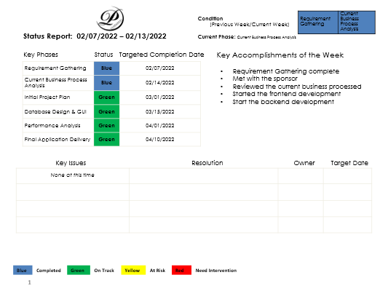

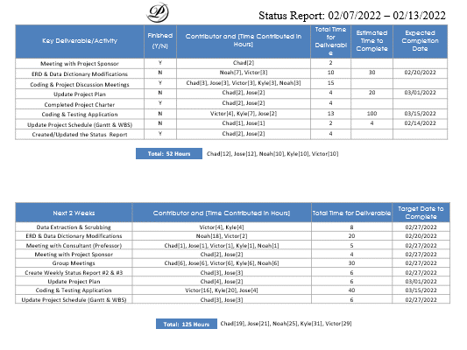

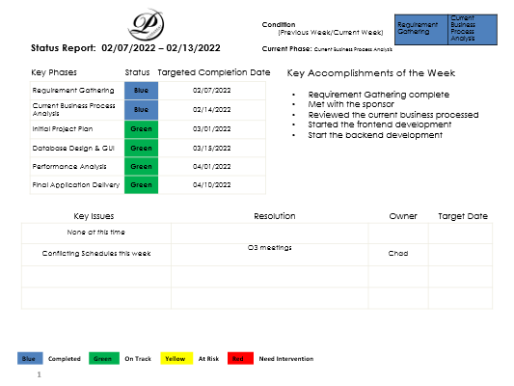



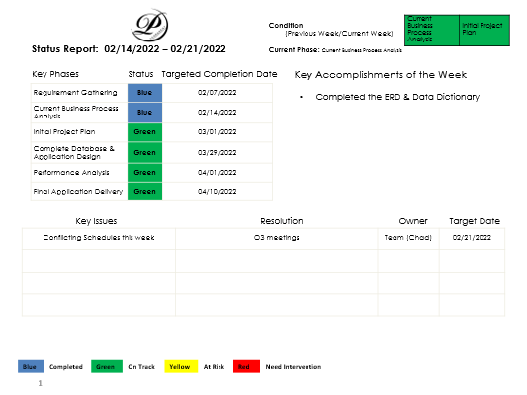

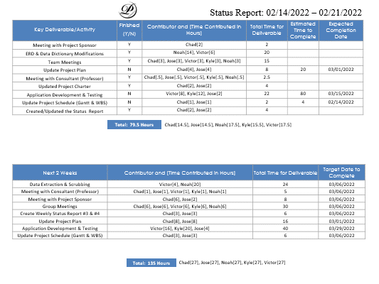

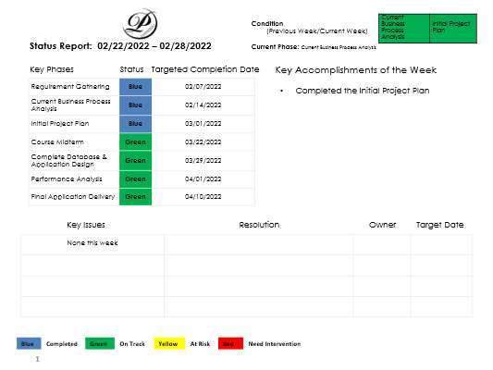

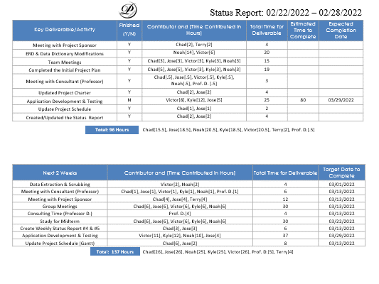

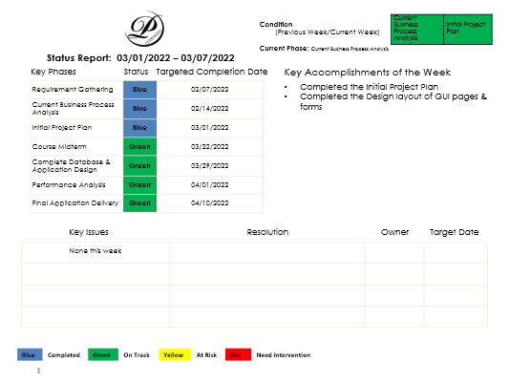

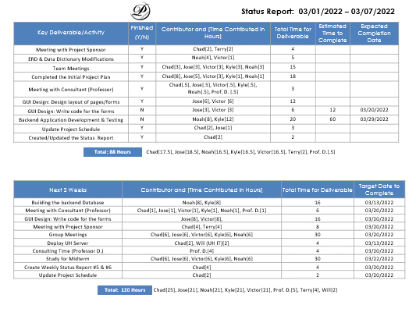

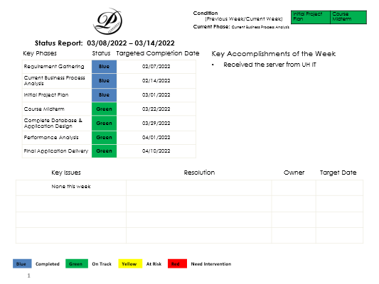

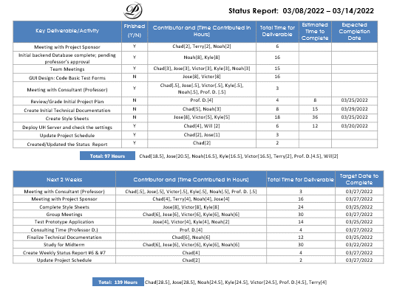

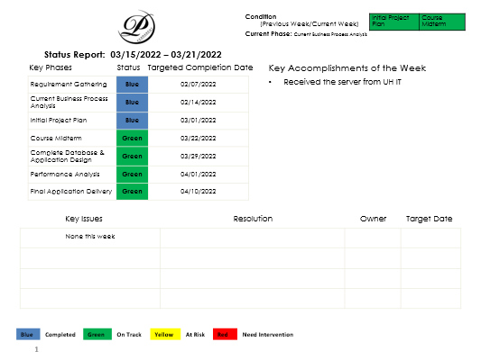

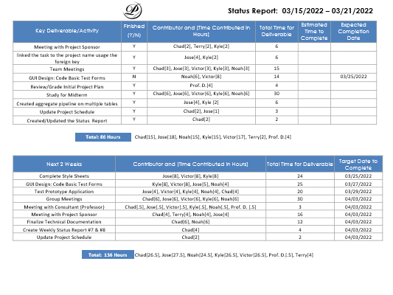

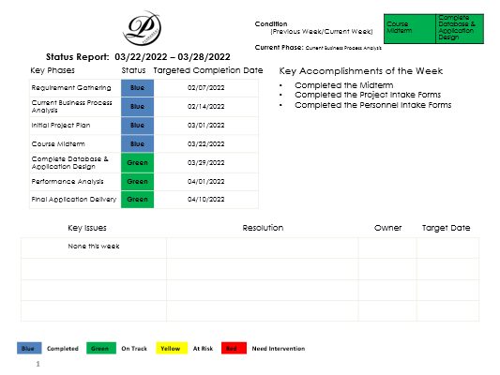

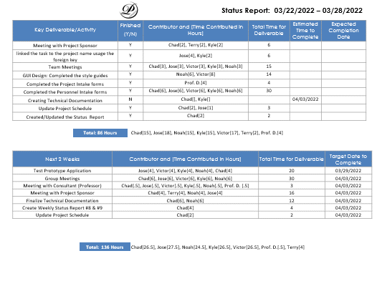

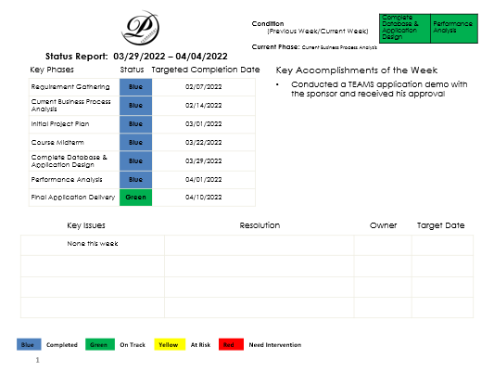

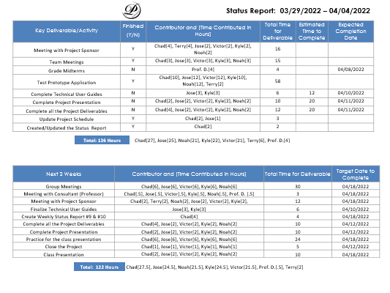

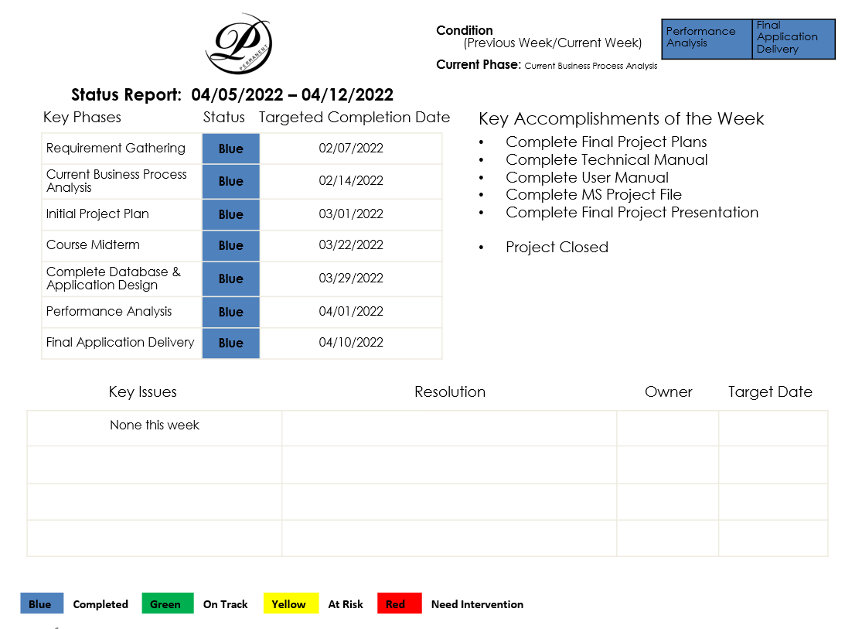

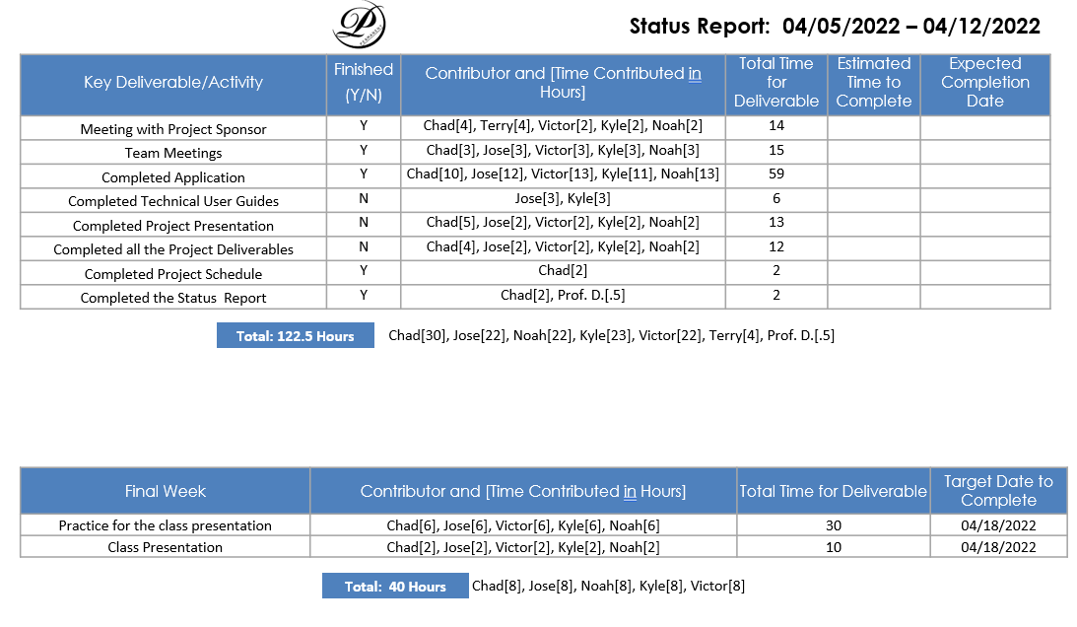

|  |  |  |  |  |  |  |  |  |  |  |  |  |
| --- | --- | --- | --- | --- | --- | --- | --- | --- | --- | --- | --- | --- |
| **Status Report Total** | | | | | | | | | | | | |
| **Name** | **Week 1** | **Week 2** | **Week 3** | **Week 4** | **Week 5** | **Week 6** | **Week 7** | **Week 8** | **Week 9** | **Week 10** | **Total** |
| **Chad** | 12 | 12 | 14.5 | 15.5 | 17.5 | 18.5 | 15 | 15 | 27 | 30 | **177** |
| **Jose** | 12 | 12 | 14.5 | 18.5 | 18.5 | 20.5 | 18 | 18 | 25 | 22 | **179** |
| **Noah** | 10 | 10 | 17.5 | 20.5 | 16.5 | 16.5 | 15 | 15 | 21 | 22 | **164** |
| **Kyle** | 10 | 10 | 15.5 | 18.5 | 16.5 | 16.5 | 15 | 15 | 22 | 23 | **162** |
| **Victor** | 10 | 10 | 17.5 | 20.5 | 16.5 | 16.5 | 17 | 17 | 21 | 22 | **168** |
| **Total** | 54 | 54 | 79.5 | 93.5 | 85.5 | 88.5 | 80 | 80 | 116 | 119 |  |

|  |  |  |  |  |  |  |  |  |  |
| --- | --- | --- | --- | --- | --- | --- | --- | --- | --- |
| **Microsoft Project Total Hours** | | | | | | | | | |
| Resource Name | Type | Initials | Max. Units | Std. Rate | Ovt. Rate | Cost/Use | Accrue At | Base Calendar | Work |
| Chad Johnson | Work | C | 200% | $50.00/hr. | $75.00/hr. | $0.00 | Prorated | Standard | 184 hrs. |
| Jose Zelaya | Work | J | 200% | $48.00/hr. | $72.00/hr. | $0.00 | Prorated | Standard | 164 hrs. |
| Noah Hendricks | Work | N | 200% | $46.00/hr. | $69.00/hr. | $0.00 | Prorated | Standard | 160 hrs. |
| Kyle Cortez | Work | K | 200% | $48.00/hr. | $72.00/hr. | $0.00 | Prorated | Standard | 160 hrs. |
| Victor Nguyen | Work | V | 200% | $46.00/hr. | $69.00/hr. | $0.00 | Prorated | Standard | 160 hrs. |

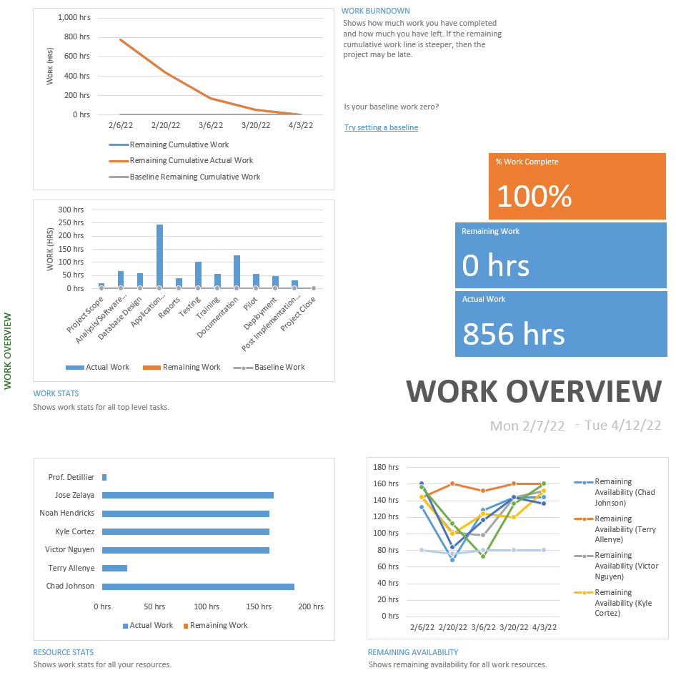

**Final Presentation Slides**

